

An Intelligent Fraud Detection System for Banking Transactions Using Machine Learning and Business Intelligence Visualization

Submitted by
Gunji Prakash Babu
Student ID: P2902637
Supervisor
Muhammad jawaid

Module: Data Analytics & CSIP5501_2025_631
De Montfort University, Leicester, UK
Email:

Acknowledgements
I would like to take this opportunity to thank De Montfort University for providing me with the academic environment that enabled me to complete this dissertation work. I would like to thank my dissertation supervisor for his/her consistent guidance and encouragement throughout this whole research process. I would also like to thank the departmental faculty members for their academic inputs. I am very much thankful to my family members and friends for being patient and supporting me in this difficult time. Lastly, I would like to thank the open-source community for their dataset on banking transactions which helped me carry out this research work.

Declaration
I, Prakash Ram, hereby state that the above dissertation titled "An Intelligent Fraud Detection System for Banking Transactions using Machine Learning & Business Intelligence Visualisation" presented to De Montfort University as part of the requirements for my degree is entirely the outcome of my own work. The sources which I used in preparing the above dissertation have been cited appropriately and in accordance with the academic policies of De Montfort University. To my knowledge, neither has the dissertation or part thereof been submitted elsewhere for another degree/diploma, nor is it likely to be submitted in the future.

Abstract
The quick rise of digitization in the banking industry has increased the likelihood of fraudulent transactions; therefore, there is a need to develop intelligent automation solutions that can effectively overcome the drawbacks associated with traditional rule-based systems. This dissertation paper outlines the development of a machine learning solution designed for fraud detection and integration with Power BI business intelligence dashboards for visualization purposes. A large set of banking transactions with 200,000 records and 24 features were used in the experiment. Preprocessing was performed by means of the following techniques: cleaning, data exploration, feature creation and selection, categorical encoding, SMOTE. Four machine learning algorithms – Logistic Regression, Decision Tree, Random Forest, and Gradient Boosting – were tested for accuracy, precision, recall, F1 score, and confusion matrix.
The results show that although Logistic Regression, Random Forest, and Gradient Boosting models provide high accuracy (around 95%), they fail to detect any fraudulent cases owing to class imbalance bias. The Decision Tree algorithm provides the highest level of accuracy and outperforms other models in terms of recall and F1 scores. It can be concluded that accuracy should not be considered as the most valuable metric for fraud detection problems. The use of Power BI dashboards significantly improves the interpretability of the model.

Contents
Acknowledgements 2
Declaration 3
Abstract 4
Chapter 1: Introduction 11
1.1 Background 11
1.2 Problem Statement 12
1.3 Aim and Objectives 12
1.4 Research Questions 13
1.5 Scope of the Study 13
1.6 Dissertation Structure 13
Chapter 2: Literature Review 15
2.1 Overview 15
2.2 Scope and Focus of the Literature Review 15
2.3 Research Methods Used in Existing Fraud Detection Studies 17
2.4 Strengths and Weaknesses in Existing Fraud Detection Literature 19
2.5 Challenges in Existing Fraud Detection Studies and Solutions Proposed in This Study 20
2.6 Theoretical Foundations Supporting Fraud Detection Systems 21
2.7 Conceptual Framework for the Proposed Fraud Detection System 23
2.8 Identified Research Gaps in Fraud Detection Studies and Addressed Them 24
2.9 Summary of Literature Review 26
Chapter 3: Methodology 27
3.1 Introduction 27
3.2 Data Collection and Preliminary Review 27
3.3 Data Validation and Quality Review 30
3.4 Outlier Analysis and Treatment 33
3.5 Data Exploration and Statistical Analysis 36
3.6 Feature Engineering 44
3.7 Categorical Encoding 45
3.8 Handle Class Imbalance 46
3.9 Summary 47
Chapter 4: Results and Analytical Discussion 48
4.1 Experimental Results Overview and Performance Summary 48
4.2 Classification Performance Analysis 48
4.3 Comparative Evaluation of Classification Models 49
4.4 Confusion Matrix-Driven Error Analysis 52
4.5 Feature Importance and Key Fraud Indicators 56
4.6 Behavioural Analysis of Transaction Patterns 57
4.7 System-Level Considerations in Fraud Detection 58
4.8 Visualisation and Dashboard Insights 58
4.9 Integrated Discussion of Model Performance 60
4.10 Key Findings and Empirical Insights 61
4.11 Summary 62
Chapter 5: Conclusion 63
5.1 Summary of Findings 63
5.2 Research Contributions 63
5.3 Recommendations 64
5.4 Future Research 65
References 67

List of Figures
Figure 1: Machine Learning Workflow for Detecting Fraudulent Banking Transactions 16
Figure 2: Machine Learning Pipeline for Banking Fraud Detection 17
Figure 3: Sample Banking Analytics Dashboard 19
Figure 4: Conceptual Framework for ML-based Banking Fraud Detection 23
Figure 5 : Bank Transaction Fraud Detection Data Loading 28
Figure 6: Bank Transaction Records 28
Figure 7: Customer Transactions 29
Figure 8: Last Customer Transactions 29
Figure 9: 200K × 24 Dataset 29
Figure 10: No Duplicates 31
Figure 11: No Missing Values 32
Figure 12: Clean Dataset Confirmed 33
Figure 13: Outlier Detection Boxplot 34
Figure 14: No Outliers Detected 35
Figure 15: IQR Outlier Check: Zero Found 35
Figure 16: Fraud Transaction Overview 37
Figure 17: Customer Behaviour Analysis 37
Figure 18: Fraud Transaction Investigation 38
Figure 19: Feature Distributions 40
Figure 20: Age vs Fraud 41
Figure 21: Transaction Amount vs Fraud 41
Figure 22: Account Balance vs Fraud 42
Figure 23: Transaction Amount vs Fraud 42
Figure 24: Correlation Matrix 43
Figure 25: Fraud Pair plot 44
Figure 26: Feature Engineering 45
Figure 27: Encoding & X/y Split 46
Figure 28: SMOTE Balancing 47
Figure 29: Performance Comparison of Classification Models 49
Figure 30: Decision Tree Classifier 50
Figure 31: Random Forest Classifier 51
Figure 32:Logistic Regression 51
Figure 33: Gradient Boosting 52
Figure 34: Confusion Matrix 53
Figure 35: Confusion Matrix -Decision Tree 53
Figure 36: Confusion Matrix 54
Figure 37: Confusion Matrix -Random Forest 54
Figure 38: Confusion Matrix 55
Figure 39: Confusion Matrix -Logistic Regression 55
Figure 40: Confusion Matrix 56
Figure 41: Confusion Matrix- Gradient Boosting 56
Figure 42: Power BI Fraud Detection Dashboard 59

List of Tables
Table 1: Summary Table 25

Chapter 1: Introduction
Rapid digitisation of banking processes has resulted in an increased number of electronic transactions (Aburbeian et al., 2023). While digitisation brings in the advantages of speed and convenience, it also raises the level of fraudulent transactions and cybercrimes against banks. Such fraudulent transactions may result in losses, damage to reputation, and decreased customer confidence in financial institutions. However, most current fraud detection strategies use rule-based algorithms that cannot cope with increasingly sophisticated fraud patterns. Machine Learning (ML) is considered to be a promising technology in this area due to its capability to analyse vast amounts of transactional data, recognise underlying patterns, and detect suspicious transactions. This study will focus on the development of an efficient fraud detection tool utilising ML algorithms, including Logistic Regression, Decision Tree, Random Forest, and Gradient Boosting. Apart from that, Power BI tools will be applied to create transaction visualisation dashboards. The research aims at creating an intelligent tool for detecting suspicious activities and increasing transaction security (Pavlova-Banova and Stoyanova, 2025).

1.1 Background
The banking and financial industry has undergone digitalisation with the emergence of online banking, mobile banking, and transactional systems. The emergence of these technologies has led to more convenient, faster and accessible transaction methods but also opened up ways to fraudulent banking activities that have led to many financial losses, operational risks and decreased customer trust (Verma et al., 2025). The main problem associated with fraud detection is its detection through traditional means and approaches, which are usually based on predetermined transaction rules and are not adaptable to the constantly changing forms of fraudulent activities. Therefore, there exists a rising need for an approach that would enable efficient detection of fraud and reduction of fraudulent activities (Lankadasu et al., 2025). Machine Learning algorithms have become an effective solution to detect suspicious patterns in transaction records. They are able to analyse large amounts of data in a way to find out unusual behaviours. The proposed research is intended to examine how Machine Learning could help detect and prevent fraud in the banking and financial sector.

1.2 Problem Statement
Due to the fast-growing development of digital banking and the usage of e-commerce, fraud risks have greatly increased in the banking industry. In view of the fact that thousands of transactions occur every day in the bank, it would be difficult to manually monitor and detect such behaviour in real time. Present-day fraud detection systems depend heavily on rules-based monitoring methods; therefore, they cannot recognise fraud activities, and it becomes impossible to detect new kinds of fraud activities. As a consequence, many fraudulent transactions remain undiscovered, causing huge monetary losses, tarnishing reputations, and undermining customer trust. Moreover, another limitation of fraud detection is that there is a significant imbalance in banking data sets, in which a very small percentage is made up of fraud.
It clearly indicates that it is necessary to create a sophisticated algorithm for detecting fraud, as it has to be able to analyse a great number of transactions, reveal fraud patterns, and improve fraud recognition rates. Machine learning techniques, along with business intelligence visualisations, could be helpful for the improvement of the fraud detection rate.

1.3 Aim and Objectives
The primary aim of this research is to develop an intelligent fraud detection system for banking transactions using machine learning techniques and business intelligence visualisation tools. The study focuses on identifying fraudulent transaction patterns, improving fraud detection capability, and supporting data-driven decision-making within banking environments.
Objectives of the Project
The key objectives of the project include:
- To analyse bank transaction data and understand patterns related to fraudulent activities.
- To preprocess and prepare the dataset for machine learning model development.
- To implement machine learning algorithms to classify transactions as fraudulent or legitimate.
- To evaluate the performance of different models using appropriate evaluation metrics such as accuracy, precision, recall, and F1-score.
- To develop interactive Power BI dashboards to visualise transaction patterns and fraud trends.

1.4 Research Questions
The following research questions guide the development of this project:
- How effectively can machine learning algorithms detect fraudulent bank transactions compared to traditional rule-based methods?
- Which transaction features have the most significant impact on identifying fraudulent activities?
- How can data visualisation tools such as Power BI enhance the understanding of fraud patterns in financial transactions?
- Which machine learning algorithm provides the highest accuracy and reliability in detecting fraudulent transactions?

1.5 Scope of the Study
This research deals with building and testing the proposed ML-based algorithm for banking transaction fraud detection based on transactional and customer data. As per the scope limitations, the research will be conducted on analysing banking transactional data for identifying the fraudulent and legit activities with the use of classification methods. Data preprocessing, exploratory data analysis, feature engineering, categorisation encoding, dealing with class imbalance, implementing ML models, and evaluating their performance are some of the topics which will be covered (Lankadasu et al., 2025). The research will be dedicated to applying ML algorithms, such as Logistic Regression, Decision Tree, Random Forest, and Gradient Boosting, to test the algorithm performance related to fraud detection. The evaluation process will include the measurement of different aspects, such as accuracy, precision, recall, F1-score, and confusion matrix analysis. Moreover, the development of interactive Power BI dashboards will be applied for visualising transaction behaviour, fraud trends, customer profiling, and risky transaction types. On the other hand, the research will be limited to historical transactional data only without covering the implementation of real-time fraud detection in the live banking environment (Albalawi & Dardouri, 2025).

1.6 Dissertation Structure
The dissertation consists of five chapters, each one discussing different aspects of the current research study. Chapter 1 introduces the introduction, background, problem statement, research aims and objectives, study scope, and general structure of the research study. The main idea here will be to introduce readers to difficulties associated with detecting fraud in contemporary banking systems and machine learning applications to these problems.
Chapter 2 introduces the literature review that examines previous studies related to the area of interest, namely fraud detection in banking, machine learning methods, class imbalance issues, and business intelligence in finance.
Chapter 3 explains the methodological approach used in this research study. This chapter discusses issues related to data collection, data preprocessing, EDA, feature engineering, data encoding, class balance with SMOTE, and machine learning models.
Chapter 4 addresses the results obtained within the experiment as well as model performance assessment, comparative analysis, behavioural insights, and data visualisation using Power BI for analysis of banking frauds.
Finally, Chapter 5 introduces the conclusions and recommendations of this research study as well as its major contribution to science and areas for future research.

Chapter 2: Literature Review

2.1 Overview
Banking transaction fraud has turned into a significant issue because of the speed of development of online payments and digital banking. This has made the process of detection quite challenging because millions of transactions are being processed by a financial institution every day, and dealing with them through conventional rule-based systems. Recent research reveals that machine learning approaches can process high amounts of transactional information and identify latent patterns that reveal suspicious conduct (Compagnino et al., 2025; Hernandez Aros et al., 2024). The popularity of machine learning algorithms can be explained by their ability to learn using past data on transactions and enhance the fraud detection efficiency in the long run. However, difficulties, including unequal datasets, in which fraudulent transactions present a minor part of the data, may decrease the accuracy of the model (Nobel et al., 2024; Wen et al., 2024). Moreover, analytical tools like Power BI can be used by organisations to understand trends of fraud and assist in making decisions based on interactive dashboards (Gonçalves et al., 2023). Hence, machine learning and data visualisation can be used to enhance fraud detection and offer useful insights to bank organisations.

2.2 Scope and Focus of the Literature Review
Fraud Detection in Banking Transactions: Recent studies indicate that fraud in financial institutions has become a significant problem in the contemporary banking system because the online banking system conducts a very high number of transactions daily. Conventional rule-based systems of detecting fraud cannot often recognise new and complicated patterns of fraud because they take recourse to pre-defined rules. Research says that machine learning algorithms are a better solution because they process great amounts of transaction data and determine unnoticed patterns regarding fraudulent activity (Compagnino et al., 2025; Hernandez Aros et al., 2024). The strategies enable financial institutions to enhance the detection rate of fraud and minimise financial losses.
Machine Learning Approaches in Fraud Detection: There are numerous investigations based on machine learning in the detection of fraudulent financial operations. Machine learning engages in learning through historical transactional data and classifying the transaction as either a legitimate one or a fraudulent one. Studies have shown that machine learning models are the most popular ones, as they can handle such varied features of transactions as transaction amount, customer behaviour, device type, and location of transactions (Preciado Martínez et al., 2025; Dichev et al., 2025). Moreover, machine learning models can be improved continuously as they are trained using updated data.
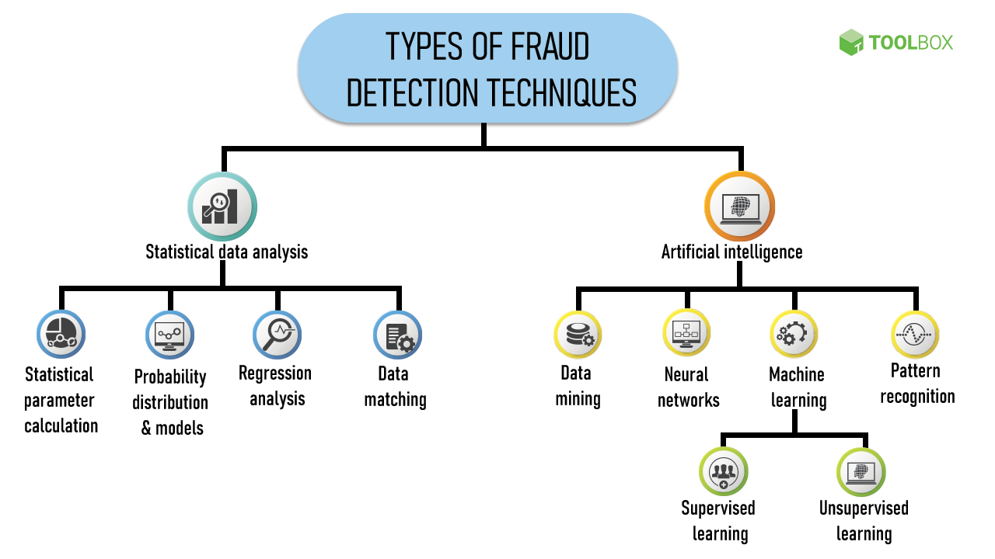
Figure 1: Machine Learning Workflow for Detecting Fraudulent Banking Transactions
(Source: Preciado Martínez et al., 2025)
Data Imbalance and Fraud Detection Challenges: The available literature points out that the dataset of fraud detection in most cases is highly skewed, i.e. fraudulent transactions form a minor percentage of the data. The imbalance would make models lean towards normal transactions and lower the detection rates of fraud (Nobel et al., 2024; Wen et al., 2024). Researchers note the significance of adequate preprocessing of data, as well as features, to enhance model performance.
Role of Data Visualisation in Fraud Analysis: The significance of business intelligence tools like Power BI in the analysis of the pattern of fraud is another important point mentioned in the recent literature. Visual dashboards can assist organisations to track the trends of the transactions, therefore, identify the suspicious activity and make decisions with the aid of obtaining a clear picture of the data (Goncalves et al., 2023). Hence, data visualisation together with machine learning analysis would be a more efficient methodology to comprehend the risks of banking system fraud.

2.3 Research Methods Used in Existing Fraud Detection Studies
Method 1: Data Preprocessing and Feature Engineering
Many existing studies indicate that proper data preprocessing is a vital technique for enhancing the performance of fraud detection. Transaction data is frequently incomplete, contaminated, and irrelevant, which may decrease the quality of machine learning models. To ensure that data is ready and model development is done, researchers, therefore, use preprocessing methods including data cleaning, feature selection, and data transformation. Indicatively, Alamri and Ykhlef (2024) point out that by examining the customer spending behaviour and choosing the major transaction aspects, it is possible to enhance the accuracy of fraud detection. Similarly, Compagnino et al. (2025) state that feature engineering can assist in the number of meaningful variables, like transaction amount, transaction location, and customer behaviour patterns, which are significantly associated with fraudulent activities. Successful preprocessing enables models to acquire more realistic patterns of the data.
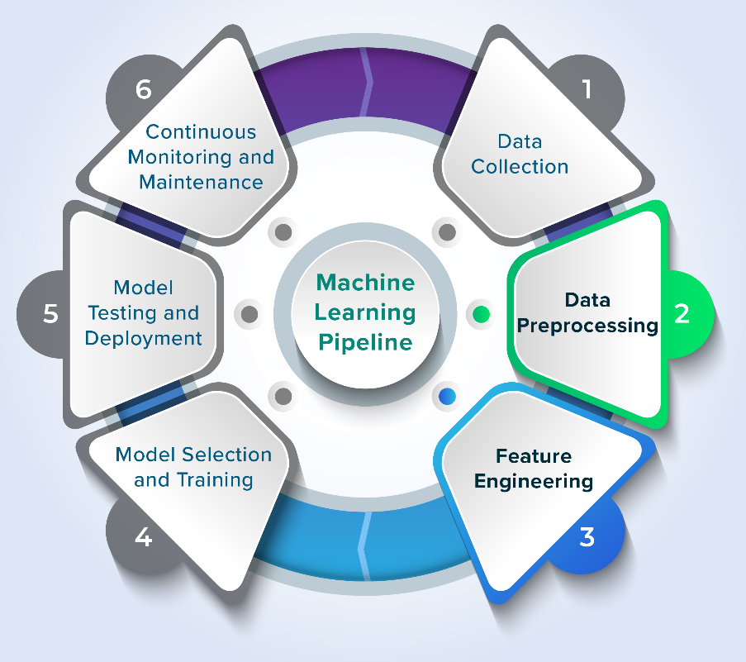
Figure 2: Machine Learning Pipeline for Banking Fraud Detection
(Source: Compagnino et al., 2025)
Method 2: Handling Imbalanced Transaction Data
Imbalanced datasets are another technique that is usually employed in fraud detection studies. In most banking data, fraudulent transactions constitute a small proportion compared to the entire data, and they can lead to models declaring most transactions as legal. In the case of this situation, data balancing methods are implemented by researchers at the data preparation phase. Wen et al. (2024) point out that the bias of the learning techniques enhances the way fraud detection systems identify infrequent fraudulent transactions. Nobel et al. (2024) also stress that it is essential to handle the imbalanced state of datasets properly to be sure that the cases of fraud will be detected properly while training the model and its analysis.
Method 3: Model Evaluation and Performance Assessment
Systematic evaluation methods are also addressed in the existing studies to indicate the effectiveness of fraud detection systems. Among the most useful performance measures that are typically used to assess a system are accuracy, precision, recall, and F1-score (Preciado Martínez et al., 2025; Dichev et al., 2025). Such evaluation methods allow the researcher to compare the various methods and choose which method of fraud detection is the most reliable.
Method 4: Visual Analytics for Fraud Monitoring
Recent research also uses data visualisation techniques to aid in fraud investigation. The visual dashboards simplify the task of an analyst to comprehend the patterns of the transactions and detect suspicious activities. According to Gonçalves et al. (2023), business intelligence platforms like Power BI can allow organisations to establish interactive dashboards that reflect the trends of fraud, insights into transactions and risks in an understandable and open manner. This method enhances decision-making and assists financial organisations in better controlling the risks of fraud.
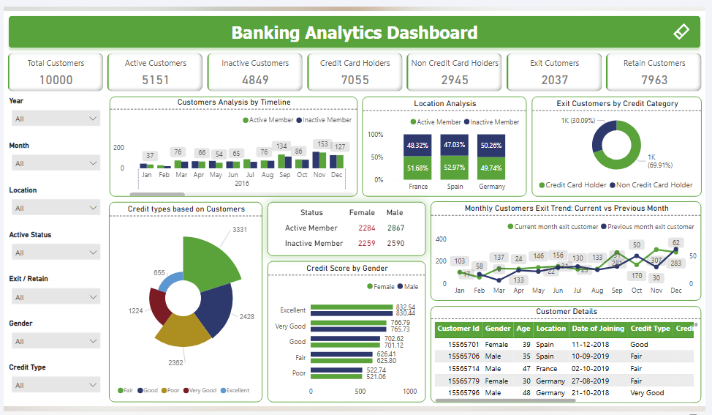
Figure 3: Sample Banking Analytics Dashboard
(Source: Gonçalves et al., 2023)

2.4 Strengths and Weaknesses in Existing Fraud Detection Literature
2.4.1 Strengths Identified in Existing Studies
Use of Data-Driven Machine Learning Approaches: One of the strengths of current studies is that machine learning has been used to identify financial fraud. Research indicates that machine learning tools can handle huge amounts of transactional data and detect sophisticated behavioural patterns that pertain to fraud. According to Compagnino et al. (2025), machine learning increases the detection of fraud because the models can be trained to identify irregularities in transactions, which cannot be identified by using a traditional rule-based algorithm. Hernandez Aros et al. (2024) accentuate that machine learning can offer more scalable and adaptive solutions for current banking settings, whereby volumes of transactions are ever-rising.
Focus on Transaction Behaviour Analysis: The focus on the customer transaction behaviour is also another strength. A study conducted by Alamri and Ykhlef (2024) shows that the accuracy of fraud detection and customer spending patterns and characteristics of transactions will be enhanced by studying their spending habits. Fraud detection systems with better distinction between normal and suspicious behaviours by analysing behavioural characteristics like frequency and amount of transactions and location could help.
Integration of Analytical Visualisation Tools: In recent research, the use of visual analytics in fraud detection is also emphasised. Goncalves et al. (2023) demonstrate that business intelligence (BI) systems like Power BI can enable organisations to develop interactive dashboards, which enable analysts to learn the patterns of transactions and realise the possibility of fraud. Visualisation enhances the process of decision-making because complex data of transactions is made clear and easy to understand.
2.4.2 Weaknesses and Limitations in Existing Studies
Imbalanced Transaction Data: The imbalance in the data sets is one of the biggest limitations that can be found in the literature. Fraud transactions only constitute a very small percentage of the data, and this can lead to the machine learning systems favouring the authentic ones and restricting fraud efficiently. According to Nobel et al. (2024) and Wen et al. (2024), this imbalance must diminish the performance of a model and seek further data balancing solutions to tackle such issues.
Limited Integration of Analytical Systems: Most studies concentrate on the development of machine learning models without paying much attention to a practical visualisation and monitoring system. As Moura et al. (2025) comment, when it comes to fraud detection studies, their analytical dashboards are most frequently missing features that would enable the financial institution to read the trends in fraud and aid in operational decisions. This gap creates a necessity for systems integrating machine learning analysis and visual tools of business intelligence.
Despite the fact that recent literature explored the depths of deep learning and neural networks in fraud detection, these approaches are not necessarily interpretable and can be very resource-intensive. There are limited studies that have examined federated learning or privacy-preserving learning methods, and there is a research gap in collaborative fraud detection across institutions. This paper fills this gap by discussing the topic of interpretability and business intelligence integration.

2.5 Challenges in Existing Fraud Detection Studies and Solutions Proposed in This Study
Challenge 1: Imbalanced Transaction Datasets
Among the most popular issues that have been reported in fraud detection research is the disproportionate transaction databases. The overall percentage of fraudulent transactions in most banking data is quite minute compared to the total number of transactions. Such an imbalance may lead to the machine learning systems classifying most of the transactions as valid, lowering the accuracy of the system to identify fraud. As Nobel et al. (2024) and Wen et al. (2024) point out, the imbalanced dataset can cause biased learning because the system tends to give more importance to normal transactions than to the frequent cases of fraud. Techniques of data balancing and proper data preprocessing in the preparation of data will be employed in this project to deal with this challenge. Effective selection of features and evaluation measures like precision, recall and F1-score will also be incorporated so that fraudulent transactions are properly detected.
Challenge 2: Poor Data Quality and Feature Relevance
Another challenge that was found in earlier research is the lack of missing values, non-relevant features, or poorly structured data in transaction data. When the data quality is poor, it may greatly affect the performance of the fraud detection system because the models will act as learners of incorrect patterns due to the incomplete or noisy data. According to Compagnino et al. (2025), to enhance the accuracy of the fraud detection system, it is necessary to perform effective data cleaning and feature engineering. To overcome this challenge, the study will entail using systematic methods in data preprocessing, which includes data cleaning, feature selection, and data transformation on the data to ensure that nothing but significant attributes of transactions are employed in the development of the model.
Challenge 3: Limited Fraud Monitoring and Interpretation
Most of the existing research is based primarily on machine learning model development and is not very supportive in real fraud monitoring and understanding. According to Moura et al. (2025), clear analytical tools are needed in financial institutions to comprehend the patterns of fraud and trends of transactions. Power BI dashboards will be created in this project in order to visualise the patterns of fraud, transactions, and risk. This will enhance the interpretability of the results and enable better decisions to detect fraud.

2.6 Theoretical Foundations Supporting Fraud Detection Systems
Theory 1: Anomaly Detection Theory
The application of anomaly detection theory is quite common in the study of fraud detection because fraudulent transactions tend to act in a different way than common financial transactions. This theory posits that abnormalities in transaction data can be used to detect suspicious behaviour, which could be in the form of fraud. According to Compagnino et al. (2025), anomaly detection enables systems to process the previous transaction history and detect transactions that cannot be depicted by the normal patterns of behaviour. Similarly, Hernandez Aros et al. (2024) note that anomaly-based methods work well in detecting rare and hidden fraud trends in financial data. The principles of anomaly detection are used in this project to support the application of machine learning methods that examine transaction characteristics like the amount of transaction, the location, and the behaviour of customers to detect unusual transactions that can be a form of fraud.
Theory 2: Data-Driven Decision-Making Theory
The data-driven decision-making theory implies that the decisions of the organisation must be made on the basis of systematic data analysis in comparison with the intuition or manual judgement of a decision-maker. Transaction data, when represented in high amounts, can provide clues in the process of detecting financial fraud. According to Dichev et al. (2025), machine learning techniques allow organisations to process complicated sets of transactions and produce valid information regarding fraud detection. This theory applies to this project through employing the machine learning models, which are trained with the past data of bank transactions. The system will identify trend patterns of the transactions and provide forecasts that will assist the financial institutions to detect transactions that are high risks more efficiently.
Theory 3: Business Intelligence and Visual Analytics Theory
The business intelligence theory is aimed at converting intricate data into valuable information to aid in making organisational decisions. Visual analytics tools enable users to interpret big data by using an interactive dashboard and graphs. Goncalves et al. (2023) highlight that business intelligence tools like Power BI enhance the interpretation of data by displaying significant indicators and trends of transactions in an easy format. Visual dashboards are useful in fraud detection systems to enable the analyst to track suspicious trends and chances of fraud more effectively. In this project, the visualisation patterns of the transactions, fraud patterns, and key indicators will be visualised using Power BI dashboards, which will enhance the comprehension of the risk of fraud and assist in better monitoring of financial transactions.

2.7 Conceptual Framework for the Proposed Fraud Detection System
The conceptual framework shows the interaction of the various elements of the proposed system to identify fraudulent banking transactions and to offer meaningful information to aid decision-making. The structure incorporates the analysis of transaction data, machine learning models, and business intelligence visualisation to enhance the performance of fraud detection.
Transaction Data Collection and Understanding: The first stage focuses on collecting and analysing banking transaction information. The common attributes in transaction datasets are transaction amount, information about customers, the type of device, the type of merchant, and the location of the transaction. These features can be used to detect behavioural patterns that could be fraudulent. According to Hernandez Aros et al. (2024), the study of historical transaction information is significant in comprehending patterns of fraud. Similarly, Preciado Martínez et al. (2025) clarify that transaction-level data gives useful information to detect unusual financial behaviour.
Data Preprocessing and Feature Preparation: The second stage is pre-processing the data to be analysed. Transaction data may have missing values, irrelevant attributes, or inconsistent formats that can impact the system performance. Therefore, data cleaning and feature selection are implemented to make sure that only significant variables are utilised. Alamri and Ykhlef (2024) highlight that machine learning systems can better detect fraud patterns when relevant transaction features are selected.
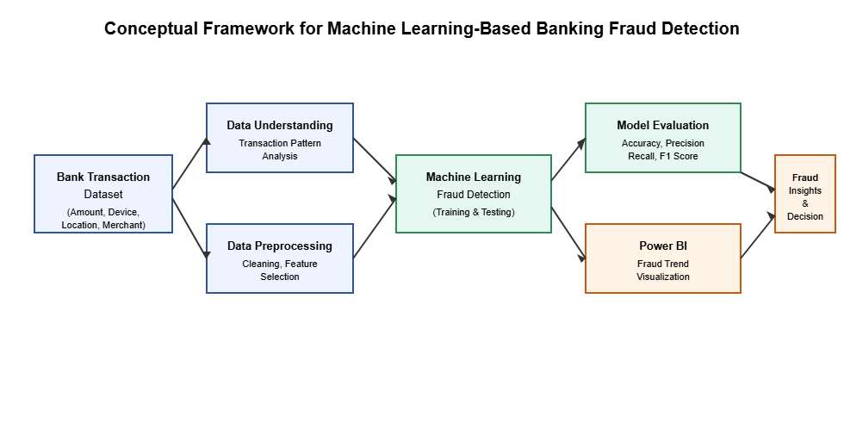
Figure 4: Conceptual Framework for ML-based Banking Fraud Detection
Machine Learning-Based Fraud Detection: The third stage implements machine learning to study transaction patterns and categorises transactions into legitimate and fraudulent. These methods build on previous transaction history and find correlations between transaction characteristics and fraudulent transactions. According to Compagnino et al. (2025), machine learning methods work best because they may identify unseen fraud patterns in extensive datasets.
Fraud Pattern Visualisation and Decision Support: The final stage is the presentation of the findings using Power BI dashboards. Goncalves et al. (2023) argue that visual dashboards allow organisations to understand the trends of transactions and watch suspicious activities more efficiently. Specifically, Power BI dashboards will present fraud patterns, transaction-related information, and risk-related data in this project to aid in more effective fraud monitoring and decision-making.

2.8 Identified Research Gaps in Fraud Detection Studies and Addressed Them
Gap 1: Limited Integration of Machine Learning with Practical Visual Monitoring
The existing literature mainly focuses on creating machine learning to identify fraud but pays little attention to the way the findings can be explained by financial analysts. According to Moura et al. (2025), some of the fraud detection investigations focus on prediction accuracy but do not offer effective tools that enable organisations to track fraud trends in real time. Likewise, Compagnino et al. (2025) point out that studies are frequently focused on the performance of technical models, but they overlook decision-support systems. To solve this gap, the suggested study will combine machine learning analysis with Power BI dashboards. The dashboards will display the trends in fraud, transaction statistics, and suspicious behaviour patterns in visual formats, and hence the results will be more interpretable by the banking professionals.
Gap 2: Insufficient Focus on Data Preprocessing and Feature Relevance
Another limitation identified in the past literature is the lack of emphasis on systematic data pre-processing and feature reading. Numerous papers focus on model development and do not have much information concerning the preparation of transaction data to be analysed. Alamri and Ykhlef (2024) indicate that meaningful transaction features like spending behaviour and transaction characteristics are crucial in detecting fraud by the systems. The preprocessing activities, such as data cleaning, feature selection, and transformation, shall be done meticulously in this project to ensure that the data reflects the real trends of fraud.
Gap 3: Challenges of Imbalanced Fraud Datasets
Imbalanced datasets are one of the primary problems in the study of fraud detection. The percentage of fraudulent transactions in most cases is a very minor fraction of the total transactions, which may decrease the detection rate of machine learning systems. Nobel et al. (2024) and Wen et al. (2024) highlight that such an imbalance may result in biased predictions in which models distinguish most transactions as legitimate. The research paper resolves the problem by ensuring that appropriate data balancing techniques are implemented and that the evaluation metrics, including precision, recall, and F1-score, are applied to guarantee that the fraud cases are adequately identified.
Gap 4: Lack of Comprehensive Fraud Pattern Analysis
Some studies address the issue of classification results only, without investigating the wider effects of transaction behaviour and the trends of fraud. According to Hernandez Aros et al. (2024), the awareness of the patterns of transactions is relevant to enhancing fraud detection systems. The current project overcomes this drawback by implementing the machine learning analysis with visual dashboards that assist in detecting behavioural patterns and trends of fraud in banking transactions.
Summary Table
Table 1: Summary Table
Author | Year | Research Outcomes | Research Limitations
Preciado Martínez et al. | 2025 | Compared machine learning techniques for detecting fraudulent banking transactions and showed improved fraud detection accuracy using data-driven approaches. | Focused mainly on model comparison with limited discussion on practical monitoring systems.
Nobel et al. | 2024 | Demonstrated that machine learning improves fraud detection on imbalanced datasets and highlighted the importance of explainable analysis. | Dataset imbalance remained a major challenge affecting prediction reliability.
Wen et al. | 2024 | Proposed improved imbalanced learning techniques to enhance fraud detection performance in financial datasets. | Method complexity limits practical implementation in banking systems.
Gonçalves et al. | 2023 | Showed that Power BI dashboards improve data interpretation and support decision-making through visual analytics. | Focused on dashboard design rather than fraud detection applications.
Compagnino et al. | 2025 | Provided a comprehensive overview of machine learning methods used in financial fraud detection. | Limited empirical validation using real banking transaction datasets.
Alamri & Ykhlef | 2024 | Demonstrated that analysing customer spending behaviour improves fraud identification. | The study focused mainly on feature engineering without full system integration.
Dichev et al. | 2025 | Highlighted the role of machine learning in managing fraud risk in banking transactions. | Limited emphasis on visual analytics and operational monitoring tools.
Hernandez Aros et al. | 2024 | Reviewed machine learning applications for financial fraud detection and identified key challenges in fraud analytics. | Provided theoretical insights but limited implementation guidance.

2.9 Summary of Literature Review
The literature review indicates that the detection of financial fraud has become a significant field of research because of the fast evolution of online banking transactions. Existing studies highlight that machine learning methods offer superior fraud detection to the rest of the existing rule-based systems as they can process large volumes of transactions and discover latent patterns. However, a few issues must be mentioned, such as skewed data sets, low data quality, and minimal integration of analytical monitoring systems. The significance of visual analytics systems like Power BI to enhance the interpretation of fraud patterns and aid decision-making is also highlighted in the literature. Therefore, this research will combine machine learning and visual dashboards to enhance the process of fraud detection and transaction examination.

Chapter 3: Methodology

3.1 Introduction
The approach used in this research involves structured data analysis in order to find patterns from bank transactional data that could be used for predicting fraud. Detecting fraud is an important issue in financial institutions since the number of fraudulent transactions is much lower than the number of valid transactions (Olowu et al., 2024). Nevertheless, fraudulent transactions result in serious financial and reputational losses. In this context, sophisticated analytical approaches and machine learning algorithms are used in practice in order to identify suspicious patterns in transactions. The methodology applied in this research is based on systematic data analysis that converts raw data into structured data to feed machine learning algorithms (Pavlova-Banova and Stoyanova, 2025).
This methodology entails data collection, data quality evaluation, outlier detection, exploratory data analysis, feature engineering, and dataset preparation. Each step in the methodology plays an important role in ensuring data reliability and proper preparation of the dataset for modelling purposes. The key objective of adopting this methodology is to make sure that machine learning models are constructed using high-quality and well-prepared data (Albert, Gómez Fernández and Náñez Alonso, 2025). Through this research, it is expected to be able to determine the patterns related to fraud in financial transactions and develop an efficient model to detect such fraud.

3.2 Data Collection and Preliminary Review
Stage one in the methodology entails the acquisition of the data set and subsequent analysis thereof. The data set used in this study is the Bank_Transaction_Fraud_Detection.csv, and the data set comprises information on customer transactions within a banking system (Chang et al., 2024). The data set consists of several types of variables, such as customer information, financial variables, transactional variables, and a fraud variable that denotes the status of a transaction being either fraudulent or non-fraudulent (Cheah, Yang and Lee, 2023).
The data set was acquired and analysed using Python through the use of the Pandas module. The data set was loaded into the analytical tool using the read_csv() command, whereby the data was transformed into the form of a Data Frame.
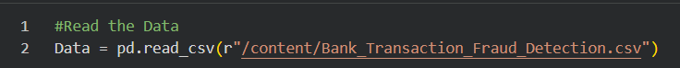
Figure 5 : Bank Transaction Fraud Detection Data Loading
The data.info () function was used for an elaborate structural examination. It gives details such as data type of the columns, counts of non-nulls per column, and memory utilisation (Albert, Gómez Fernández and Náñez Alonso, 2025).
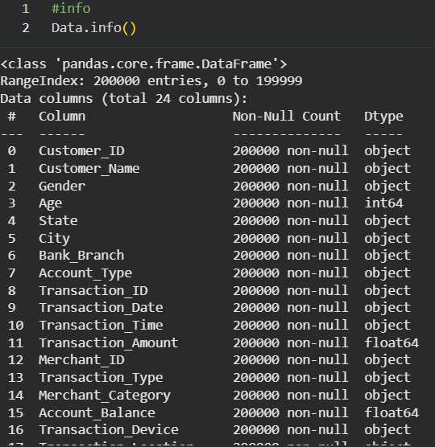
Figure 6: Bank Transaction Records

After the loading of the dataset, several steps were carried out to ascertain that the data was successfully imported and to get a general understanding of the dataset. Some of the methods used included the use of the head() and tail() methods, which gave the first and last rows of the data, respectively, and finally the shape() method to determine the number of observations and variables in the dataset.
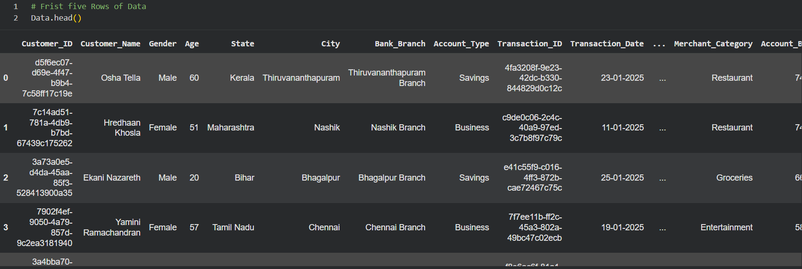
Figure 7: Customer Transactions
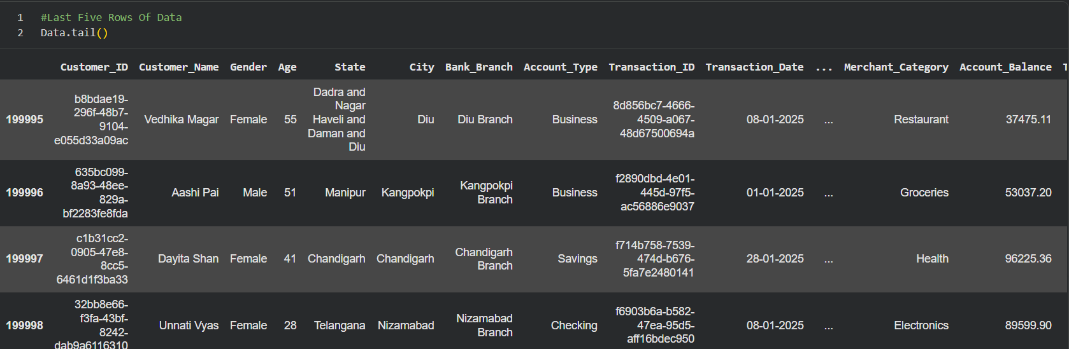
Figure 8: Last Customer Transactions

Figure 9: 200K × 24 Dataset
The preliminary inspection step guarantees that there will be clarity on how the dataset is structured before proceeding to other stages of the analysis process. The process can also help to detect any data quality problems in the early stage of the analysis, enabling any necessary correction measures to be taken in the preprocessing stage.
Overview of Dataset
The dataset being analysed has 200,000 observations and 24 variables, thus making it a vast collection of transaction records from various customers. Each record is associated with a distinct Customer_ID, ensuring that different features of each individual client can be traced. The demographic features in the dataset include Customer_Name, Gender, Age, State, City, and Bank_Branch. The financial features in the dataset include Account_Type, Account_Balance, and Transaction_Amount. From the first and last rows inspected, the dataset reflects diversity across states (e.g., Telangana, Chandigarh, Manipur) and transaction categories (e.g., Groceries, Electronics, Health, Restaurants).
There is considerable variance in the account balances, ranging from 37K to 96K, signifying a range of capabilities. With such a huge amount of data as 200,000 records x 24 attributes, there would be no problem in getting sufficient variation in data to train and test machine learning models. All in all, there is a lot of information contained within the data that gives insight into customer demography, financial stability, and behaviour regarding transactions.

3.3 Data Validation and Quality Review
High-quality data is an essential aspect as it has a direct impact on how reliable and accurate the results provided by the machine learning models will be (AbouGrad and Sankuru, 2025). Poor quality of data could result in biases and affect both the performance of models and their results. Thus, an evaluation of data quality was performed as a preliminary step.
Two major problems that often occur in real-life datasets were considered in particular during data quality evaluation:
- Record duplications
- Missing data
Both of these problems should be addressed because duplicate records might influence statistics, while missing data could negatively affect the learning of models.
Having ensured high data quality during the process, we move on to the next steps in the analysis.

3.3.1 Redundancy Identification and Elimination
One of the key tasks in the process of data preprocessing is checking the presence of duplicates within the dataset to enhance data reliability and accuracy. The occurrence of duplicate transactions could have a negative effect on the performance of the model due to the overrepresentation of some transaction records. Therefore, a routine check of data redundancy was conducted with the use of conventional data validation techniques.
The findings revealed that there were no duplicates in the dataset since each transaction record was unique. Consequently, there was no need for any action related to removing duplicates or data elimination. It is also important to note that finding and deleting redundancy within the dataset is essential for increasing data integrity and boosting computational efficiency when training the model. As the dataset was not contaminated with duplicates, it was possible to proceed directly with data preprocessing.
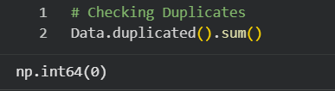
Figure 10: No Duplicates
3.3.2 Missing Data Imputation and Treatment
The dataset was scanned for missing values through null value detection in the process of data preprocessing. It was found that there were no missing values in the data in any of the features, including the customer attributes, transactions, and dependent variable. Therefore, the data is fully complete and does not have any missing values that might require data imputation using mean, median, or mode methods.
As missing data may influence the predictive models adversely and cause bias, it is crucial that the presence of missing data is detected early on. In this case, since missing data was absent from the data, its initial distribution remained unchanged.
Other factors, such as the consistency of data and its completeness, were also taken into account during the analysis and further preprocessing steps. For this reason, the efforts were concentrated on performing other processes, such as feature engineering and encoding.
function:
Data.isnull().sum()
This function returns the number of missing values in each variable of the data set.
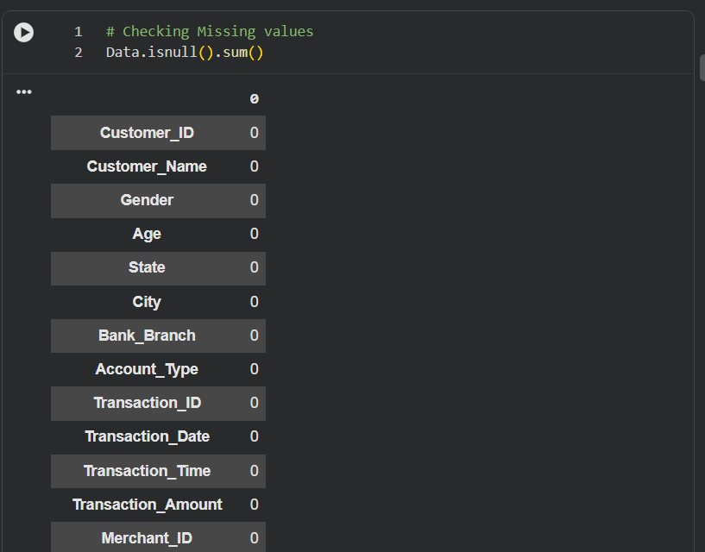
Figure 11: No Missing Values
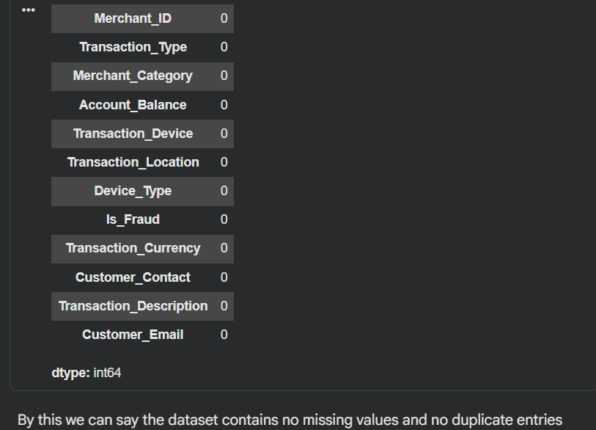
Figure 12: Clean Dataset Confirmed

3.4 Outlier Analysis and Treatment
An outlier is any data point which is quite far from most other points in the data set. Outliers could be characterised by large transactions, unexpected account balances or uncommon customer behaviour in financial transactional data. Outliers arise due to errors or fraudulent activities in some cases, while at others they could denote normal high-value transactions (Rashedi et al., 2024).
In statistics and machine learning, outliers have the potential to affect the process negatively. Hence, the detection of outliers is vital. This paper makes use of IQR (Interquartile Range) for the detection of outliers.

3.4.1 Outlier Detection Using Box Plot
The outliers were analysed by employing boxplot charts, which are used to visually display the distribution of numeric variables. Boxplots show the median, quartiles, and possible outliers of the data set.

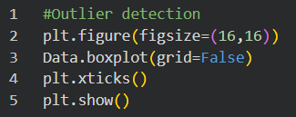
Figure 13: Outlier Detection Boxplot

The Interquartile Range (IQR) is calculated as the difference between the third quartile (Q3) and the first quartile (Q1):
IQR = Q3 − Q1
Potential outliers are identified using the following boundaries:
Lower Bound = Q1 − 1.5 × IQR
Upper Bound = Q3 + 1.5 × IQR
Values falling outside this range are considered extreme observations.

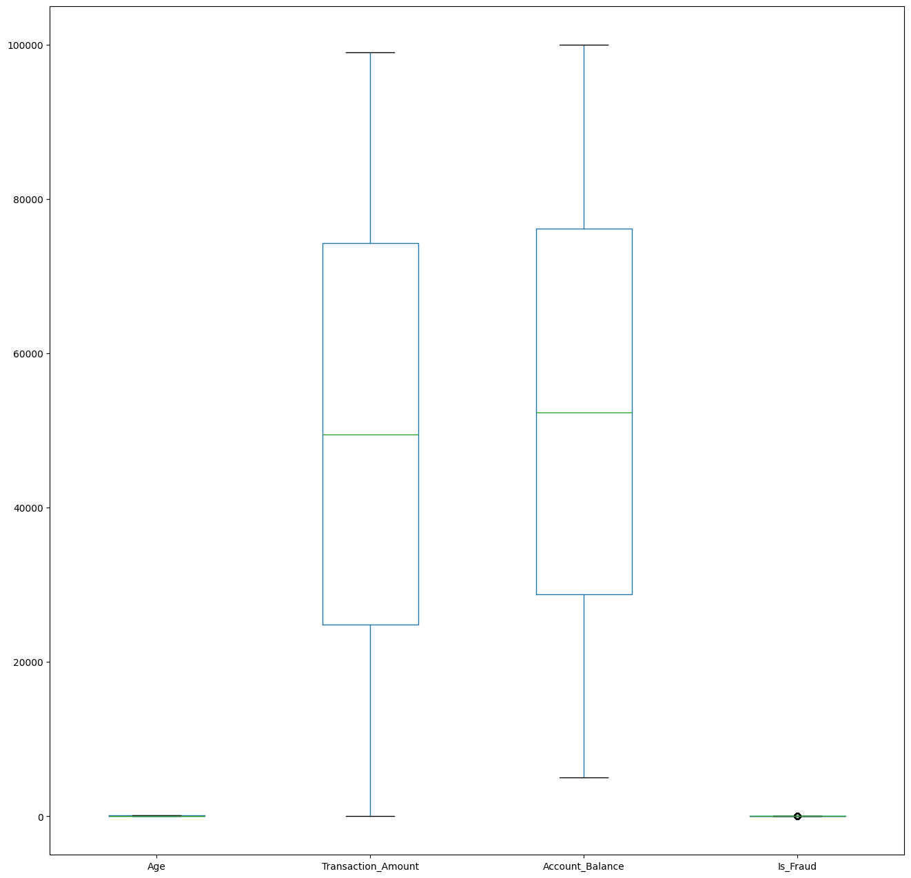
Figure 14: No Outliers Detected

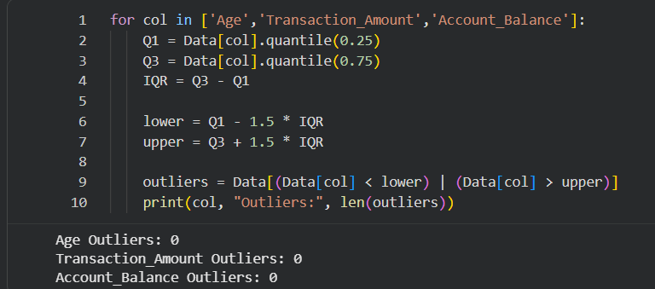
Figure 15: IQR Outlier Check: Zero Found
Outlier analysis was mainly conducted to gain insight into the distribution and variation of financial behaviour. Thus, this method ensures that any potential signal for fraud will not be omitted from analysis by the machine learning algorithms.

3.5 Data Exploration and Statistical Analysis
3.5.1 Dashboard Design and Data Visualisation Using Power BI
Prior to applying machine learning algorithms, exploratory data analysis was performed on the bank transaction fraud dataset by utilising Microsoft Power BI to reveal the existence of underlying patterns and trends. Three interactive dashboard pages have been designed that offer a visualisation of transaction behaviours, customers' demographics, and detailed information regarding fraud transaction investigations (Verma et al., 2025).
A dashboard has been created in Microsoft Power BI for the analysis of transaction data to detect the occurrence of fraud patterns. This dashboard has been segmented into three segments named: Fraud Transaction Overview, Customer Behaviour Analysis, and Fraud Transaction Investigation.
The Fraud Transactions Overview page presents various statistics, including the number of transactions, fraud cases, fraud ratio, total transaction amounts, and average transaction amounts. Various visuals have also been used to detect fraud patterns (Olowu et al., 2024).
Customer Behavior
This visual concentrates on the customer's demographic and behaviour data, such as age, gender, account balance, and fraud rate. The graphs illustrate that certain customers are linked to fraud activities.
Investigation
This visual offers a more in-depth investigation of individual transactions using filters and conditional formatting.
Conclusion
In conclusion, the developed dashboard is effective for monitoring and analysing the fraud activity trends.
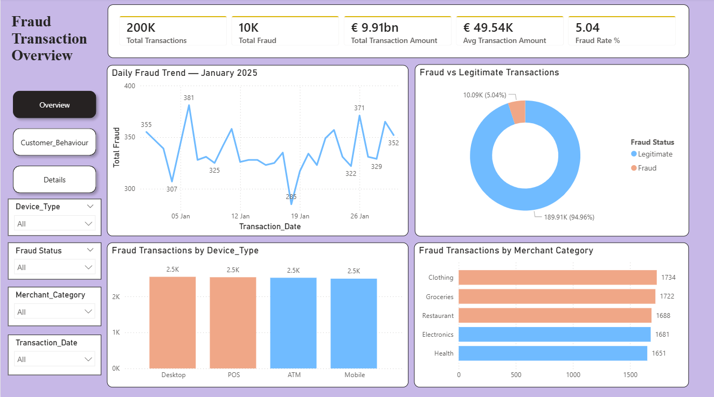
Figure 16: Fraud Transaction Overview

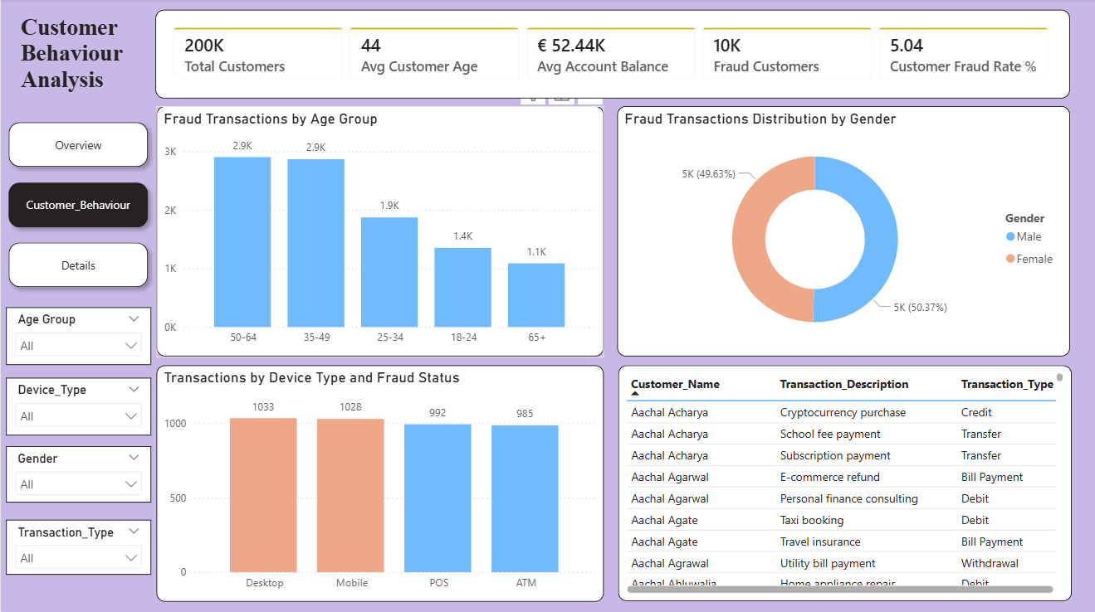
Figure 17: Customer Behaviour Analysis

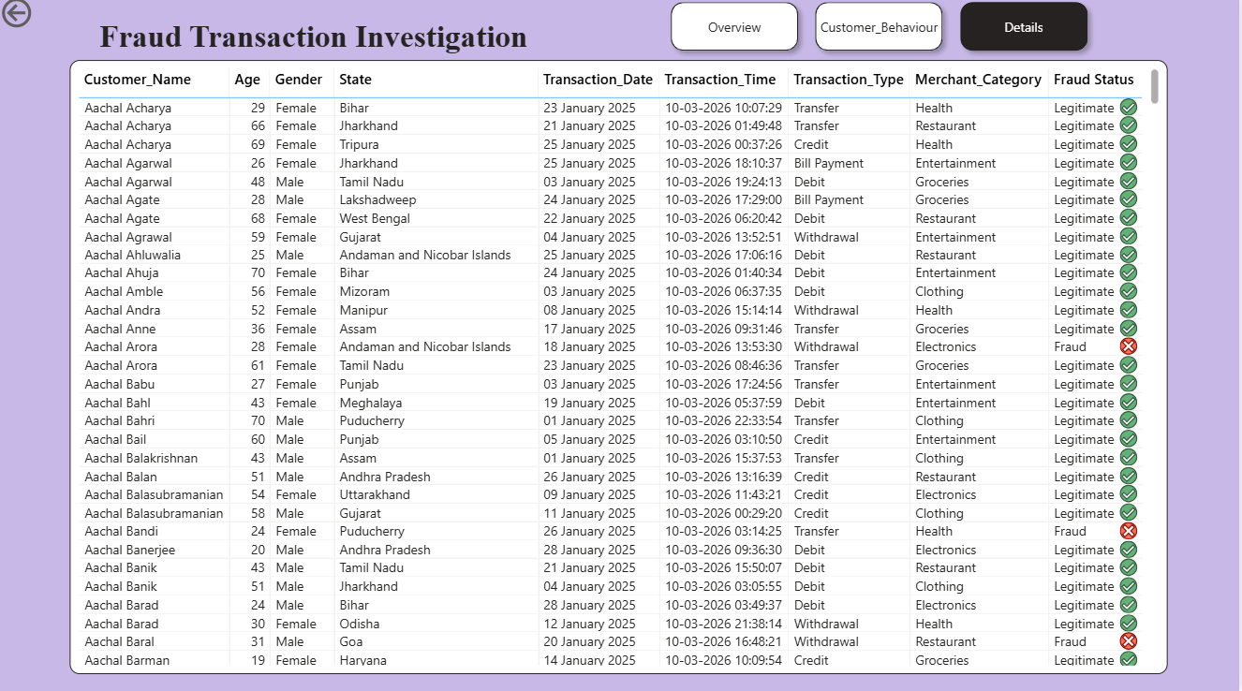
Figure 18: Fraud Transaction Investigation
3.5.2Statistical analysis
Exploratory Data Analysis (EDA) was carried out on the duplicated copy of the cleaned data set (df_EDA). The exploratory data analysis included four moments that were associated with measures of central tendency, dispersion, skewness, and kurtosis (Chang et al., 2024), respectively, in addition to correlation and visualisations from both Univariate and Bivariate/Multivariate perspectives.
First Moment – Measures of Central Tendency
The central tendency measures, such as mean, median, and mode, were computed for the numerical variables.
Some important findings are as follows:
- The average age of customers is 44 years.
- The average amount per transaction is 49,538.
- The average bank balance is 52,437.
Second Moment – Measures of Dispersion
Various dispersion measurements were performed, such as standard deviation, variance, and range, to determine the spread of data values.
For instance:
- Transaction value standard deviation = 28,551
- Account value standard deviation = 27,399
This shows that there is high variability in the transaction and account values of customers.
Third Moment – Skewness
A skewness test was carried out to determine the distribution symmetry.
Most numerical variables had nearly zero skewness, implying a fairly symmetric distribution. In this case, the fraud variable had positive skewness, which implies an unevenness in the distribution of fraudulent vs non-fraudulent transactions.
Fourth Moment – Kurtosis
Kurtosis was calculated to measure the shape of a distribution and the existence of outliers.
High kurtosis was identified in the distribution of the fraud variable, suggesting that fraudulent transactions are infrequent and extremely different from normal transactions.
Univariate Analysis
To show the distribution of numerical variables, histograms with KDE curves were plotted.

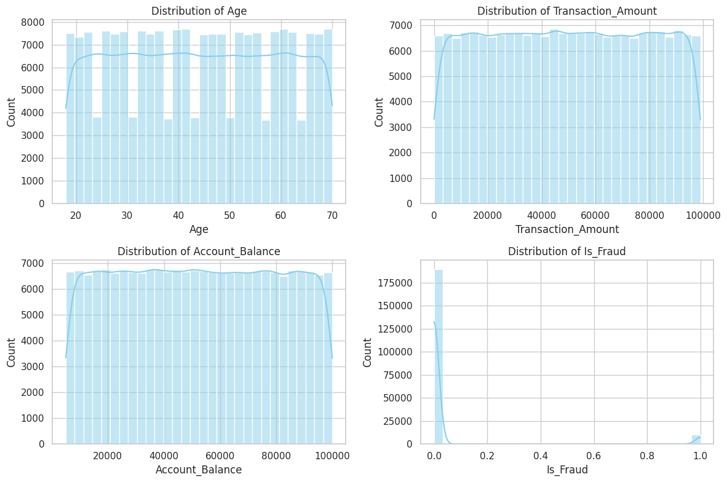
Figure 19: Feature Distributions

Bivariate Analysis
Boxplots were created for comparing numerical variables with the fraud indicator variable (Is_Fraud). These graphs were used to find any relationship between transaction features and fraud.
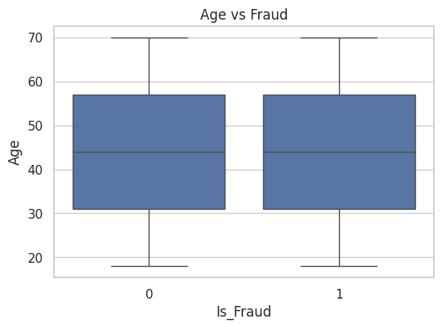
Figure 20: Age vs Fraud
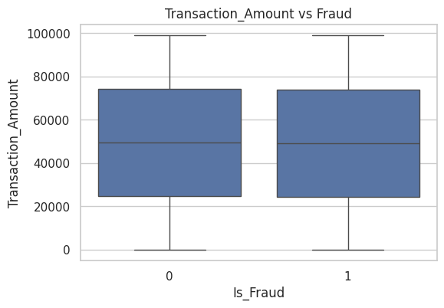
Figure 21: Transaction Amount vs Fraud
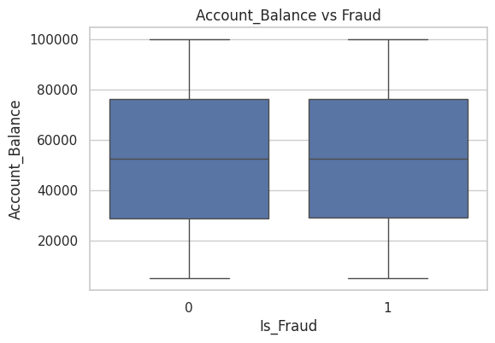
Figure 22: Account Balance vs Fraud
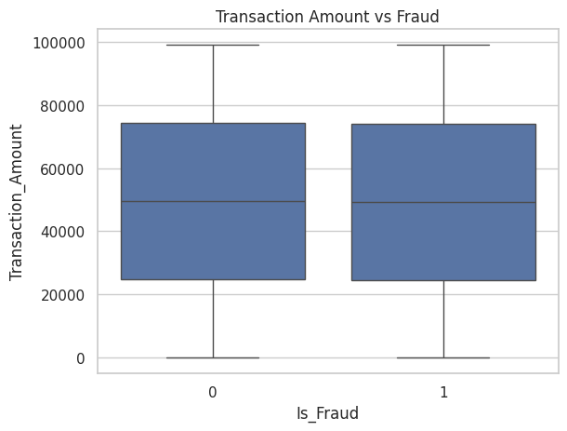
Figure 23: Transaction Amount vs Fraud
Multivariate Analysis
The correlation between numerical attributes was established through heatmap visualisation.
sns.heatmap(Data_EDA[numerical_attributes].corr(), annot=True)
Apart from that, pairplots and scatterplots have been used to determine the relationship between transactions, account balance, and fraud.
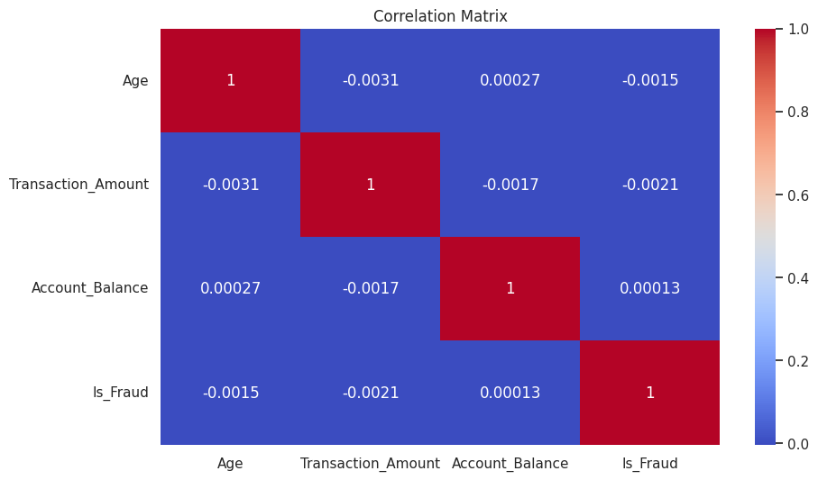
Figure 24: Correlation Matrix
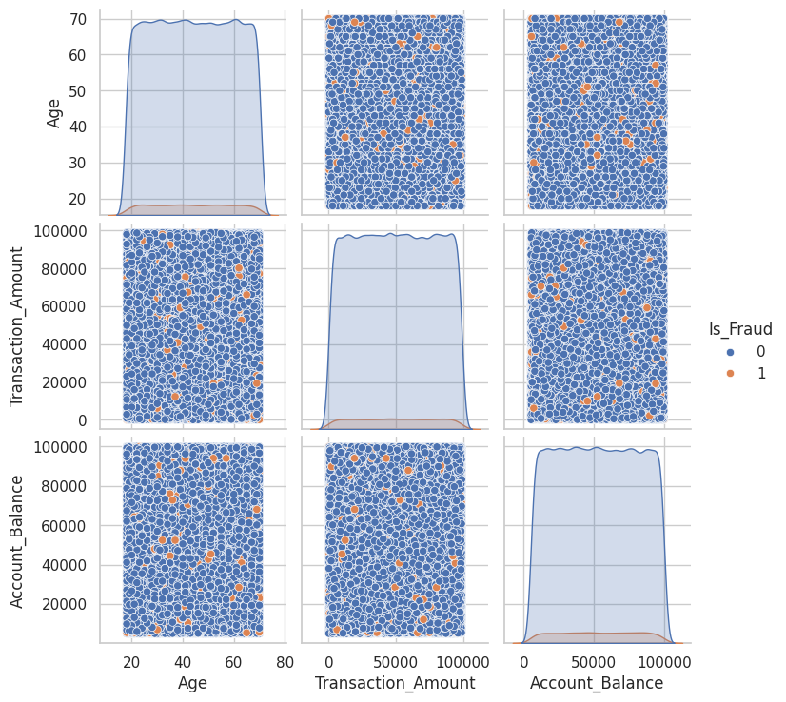
Figure 25: Fraud Pair plot

3.6 Feature Engineering
One method that was used to improve the accuracy in predicting the results of the dataset included the use of feature engineering. Time-related features such as transaction time and day of the week were created by analysing the columns of the Transaction_Date and Transaction_Time to understand the time-based patterns of fraud (Lankadasu et al., 2025).
The categorical features, Transaction_Type, Merchant_Category, Device_Type, and gender, were then converted to numerical values using different encoding methods to ensure that they could be fed into a machine learning algorithm. Useful numerical features, such as Transaction_Amount and Account_Balance, were kept to provide further information regarding transactions.
Some unnecessary features, such as Customer_Name, Transaction_ID, and Customer_Email, were removed because they did not contribute significantly to detecting fraud.
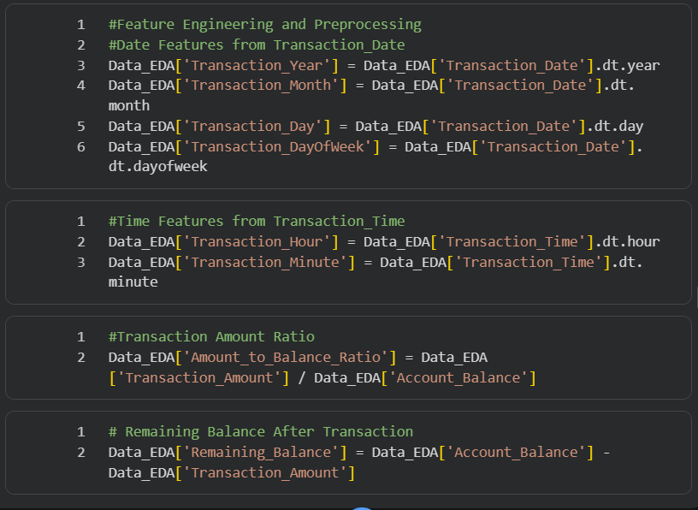
Figure 26: Feature Engineering

3.7 Categorical Encoding
Categorical encoding was performed to convert non-numerical variables into a form which could be used in machine learning models. There were multiple categorical variables present in our dataset, such as Gender, State, City, Account_Type, Transaction_Type, Merchant_Category, Transaction_Device, and Device_Type (Che Yaacob, Hashim and Yaacob, 2025). For using these variables in a machine learning model, we needed to convert them into numerical form.
For doing so, we mainly used one-hot encoding. One-hot encoding helps us to create multiple binary columns from a single categorical variable. This makes sure that we do not make any assumption regarding the ordinality between categorical variables. For converting categorical columns into binary columns, we used the 'pd.get_dummies()' command.
Variables like Customer_Name, Transaction_ID, and Customer_Email having high cardinality were dropped in order to avoid problems related to multicollinearity and overfitting.

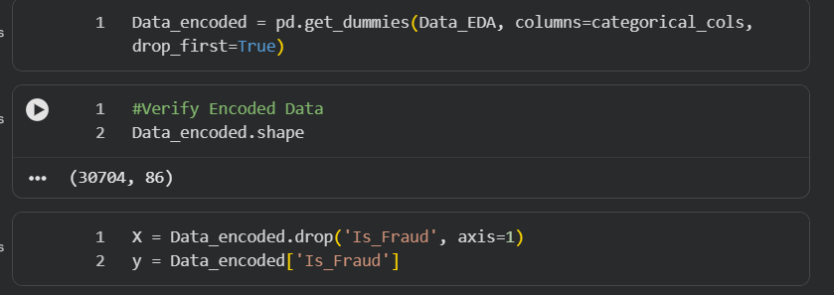
Figure 27: Encoding & X/y Split

3.8 Handle Class Imbalance
The target variable, Is_Fraud, had a notable class imbalance, with legitimate transactions making up around 95% of all records, whereas fraudulent transactions comprised roughly only 5% of the data. Such an imbalance may affect the performance of machine learning models as algorithms will favour predicting the majority class (Che Yaacob, Hashim and Yaacob, 2025). This way, detecting any fraud will be challenging since most fraud cases will not be detected.
To balance classes, SMOTE was used (Bounab, Zarour and Khlifa, 2025). The synthetic minority oversampling technique is known to create synthetic records for the minor class (in this case, fraudulent transactions). This helps balance out the number of records and improves learning as a result. However, the use of SMOTE was limited to the training set only to avoid any data leakage (Hayat and Magnier, 2025). Thus, applying SMOTE to the training data helped increase the chances of successfully predicting fraud.
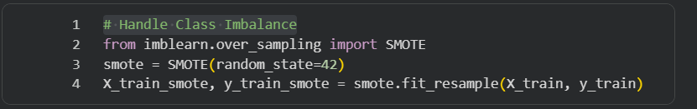
Figure 28: SMOTE Balancing

3.9 Summary
In this chapter, the methodological approach towards detecting fraud based on transaction data from banks is described. It involves a number of activities, such as data preparation and data understanding, during which the dataset is analysed, validated, and prepared for further use. Since there were no missing values or duplicates, data quality is assumed to be very high. The process of feature engineering includes generating useful variables, mostly temporal, while categorical variables are transformed into a numeric format, and the irrelevant variables with very high cardinality are dropped from the dataset.
It has been discovered that the dataset under consideration is unbalanced, since there are relatively few instances of fraud among all transactions. To tackle this problem, an algorithm called SMOTE was employed to create the balanced version of the training set.

Chapter 4: Results and Analytical Discussion

4.1 Experimental Results Overview and Performance Summary
This study examines the accuracy and efficiency of using machine learning models based on classification to identify fraudulent financial transactions conducted through banks. The main purpose of this research was to accurately classify the transactions into two categories, fraud transactions and valid transactions, while making as few mistakes as possible, especially false negative mistakes that denote fraud that goes unrecorded. The data used in this research was extremely unbalanced because there were very few fraudulent cases compared to valid cases in the entire data set.
The following three models were developed and analysed based on performance parameters like accuracy, precision, recall, and F1 score: Logistic Regression, Decision Tree, and Random Forest. Although Logistic Regression performed well in terms of accuracy, it was unable to detect any fraudulent transaction cases, thus providing zero recall (Albalawi & Dardouri, 2025). The Decision Tree model improved to some extent by detecting a few fraud transaction patterns, but was not able to generalise. The Random Forest model performed better than both the Logistic Regression and Decision Tree models because of its ensembling property.
However, even though the model performed slightly better, the recall rate of fraud detection was still poor among all the models, which reflects the problem caused by the imbalanced data set. It suggests that while the classification of transactions is accurate, the identification of fraud is not always reliable. Hence, using metrics like recall and F1-score gives us a more realistic evaluation of the model's performance than using accuracy.

4.2 Classification Performance Analysis
Model performance for classification was assessed using metrics such as accuracy, precision, recall, and F1-score to give a complete evaluation of their efficacy in identifying fraud in the dataset. Since the dataset was highly imbalanced, with only a small percentage of the data being fraudulent, the measures recall and F1-score were considered more important than accuracy. This is due to the fact that accuracy alone can sometimes be misleading in cases of imbalanced classification. The Decision Tree algorithm was applied initially, and its performance was fairly decent. As it managed to identify a number of non-linear relationships in the dataset, it successfully identified some fraud as well. The recall score of the Decision Tree classifier was around 6.59%, and the F1-score was at 5.08%, which made it more competent in identifying fraud compared to other algorithms. However, it lacked accuracy and had an issue of overfitting. The Random Forest algorithm increased the accuracy rate by 94.9% through its ensemble learning strategy, which helps in reducing variance and stability. However, the model performed very poorly in terms of recall and F1 score, which shows that the model was unable to classify the fraudulent transactions accurately. It implies that the model was biased towards legitimate transactions (Aburbeian et al., 2023).
The Logistic Regression model was also employed as a baseline, but it attained high accuracy yet failed to detect any fraud case at all, hence a perfect zero for precision, recall, and F1-score values. Due to its linearity and susceptibility to imbalanced classes, it was unable to detect fraud cases effectively. Likewise, the Gradient Boosting algorithm exhibited high accuracy but low recall and F1-score values, suggesting no significant improvement in fraud detection capabilities. In conclusion, the study demonstrates that while ensemble models boost the accuracy rate, they cannot be relied upon for enhanced fraud detection in the absence of class balance.

4.3 Comparative Evaluation of Classification Models
Comparison between different models reveals a crucial point: accuracy does not always guarantee successful fraud detection. Although the accuracy of such algorithms as Random Forest, Logistic Regression, and Gradient Boosting was near 95%, their ability to detect fraud was poor, as indicated by the very low values of recall and F1-scores. The Decision Tree model, on the other hand, although its accuracy was about 87.6% only, managed to detect some instances of the minority class, indicating its slightly better performance than the other two algorithms.
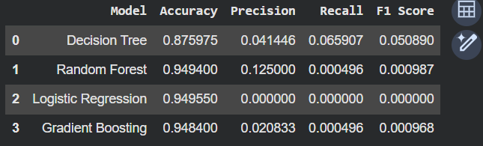
Figure 29: Performance Comparison of Classification Models
4.3.1 Decision Tree: Classification Performance Analysis
The decision Tree model was developed as the first classification algorithm to detect fraud. It is a tree-like model created by dividing input data into different branches according to their feature values. Decision Tree models can be easily interpreted since they include a structure of decision rules. This advantage plays an important role while detecting fraud because decision rules can help detect suspicious transactions (Kulbayeva et al., 2024). In this experiment, the Decision Tree model reached an accuracy rate of around 87.6%. While other models have better accuracy, this rate is not sufficient for determining the efficiency of this model at fraud detection. Decision Tree has been successful in detecting some of the fraud because it obtained 6.59% recall score and 5.08% F1-score rate. Even though these rates may seem low, they are higher than those of other models that could not detect any fraud.
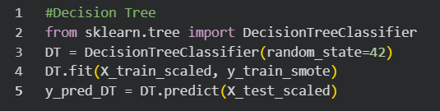
Figure 30: Decision Tree Classifier
This shows one crucial finding: Models that have less accuracy may still be better suited for predicting minority class cases like fraud. The Decision Tree model could detect some non-linear dependencies in the dataset, allowing it to detect cases of fraud that other models were unable to detect. This model is susceptible to overfitting, which may affect its performance on new unseen data.
4.3.2 Random Forest: Classification Performance Analysis
Random Forest was deployed using the ensemble learning methodology to enhance classification efficiency. Its working involves the creation of numerous decision trees and consolidating their outputs to minimise overfitting and ensure model consistency. As such, the Random Forest algorithm proves superior to the Decision Tree model in this regard. The model had an outstanding classification accuracy of around 94.9% for this case. Nonetheless, a closer look at the model's performance shows that its output falls short of expectations. In particular, the model had extremely poor sensitivity and F1 score values, implying that it could not classify most fraudulent cases correctly.
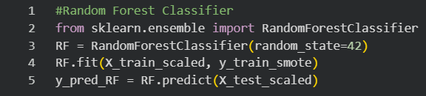
Figure 31: Random Forest Classifier
The most important point from the above is that high accuracy is no assurance of being a useful tool for fraud detection. Despite its complex ensemble architecture, Random Forest had trouble picking up any patterns in regard to the minority class of fraud cases (Velarde et al., 2023). This underscores the issue of class imbalance because the classifier was more interested in overall accuracy than in identifying fraud cases. While Random Forest proved itself to be highly robust and generalised, the inability to identify fraud diminishes the usefulness of the algorithm in practical applications.
4.3.3 Logistic Regression: Classification Performance Analysis
Logistic Regression was applied as the first algorithm for binary classification of fraudulent and non-fraudulent transactions. It provides the probability of a transaction being fraudulent based on a linear function of independent variables, thus being a fast, straightforward, and interpretable method. Logistic Regression demonstrated an excellent accuracy level of about 94.9% in the present research. Nonetheless, the performance results of Logistic Regression are biased for this problem setting. The model yielded no values of precision, recall, and F1 score, implying its inability to detect any fraudulent instances.
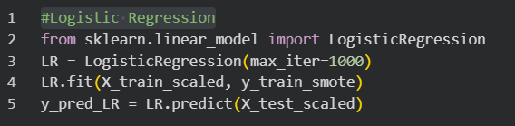
Figure 32:Logistic Regression
It reveals one major drawback of Logistic Regression, which is the assumption of linearity and class imbalance sensitivity. Detecting fraud is typically a task that has intricate patterns, which this model cannot efficiently learn. It becomes hard to detect cases of fraud, which might be infrequent. The important lesson here is that a model can seem very accurate but fail to perform the function of detecting fraud effectively. Logistic Regression helps serve as a basis of comparison, but since it fails to detect any fraudulent transactions, it cannot perform fraud detection tasks.
4.3.4 Gradient Boosting: Classification Performance Analysis
The Gradient Boosting algorithm was trained as an advanced machine learning method, which is meant to enhance prediction accuracy through the iterative combination of weak learners, usually decision trees. In contrast to the Random Forest method, in which trees are trained individually, the Gradient Boosting algorithm constructs them sequentially, training each new tree to minimise the residual error from the previous one (Yapp & Yeh, 2026). Thus, the algorithm can identify more complicated patterns in data. In our study, Gradient Boosting demonstrated excellent accuracy with values of about 94–95%, comparable with the Random Forest and Logistic Regression models. Despite using an advanced learning method, Gradient Boosting generated extremely low values for recall and F1-score, suggesting that the algorithm performed poorly in detecting fraud. Predictions were largely biased towards the majority class.

Figure 33: Gradient Boosting

4.4 Confusion Matrix-Driven Error Analysis
The confusion matrix is a tool for analysing the performance of machine learning models, where the predictions are grouped into four types: true positive (TP), true negative (TN), false positive (FP), and false negative (FN). In fraud detection, the most important indicator is the number of false negatives because they are the fraudulent transactions that were missed during the analysis. All the models performed well in terms of the number of true negatives since they were able to predict all legitimate transactions based on the fact that the majority of samples belong to the majority class. However, the most significant problem is that the models made many false negative errors. It is worth noting that the most significant number of false negatives was observed in the Logistic Regression, Random Forest, and Gradient Boosting models because they could not recognise the majority of fraudulent transactions. Therefore, these models had poor recall and F1-scores.
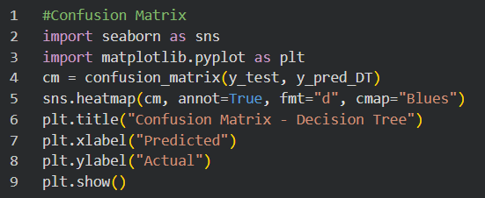
Figure 34: Confusion Matrix
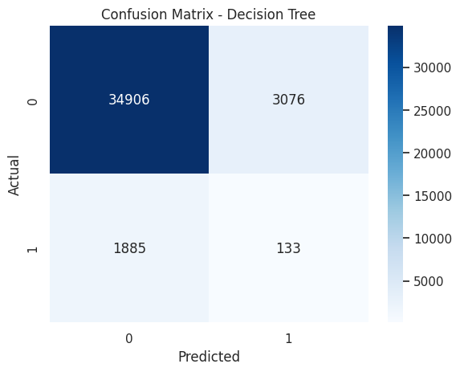
Figure 35: Confusion Matrix -Decision Tree
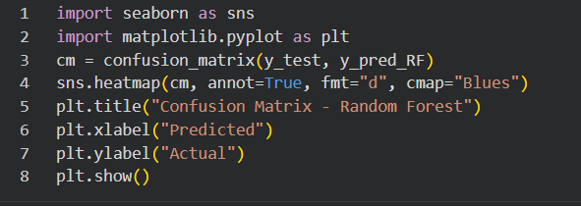
Figure 36: Confusion Matrix
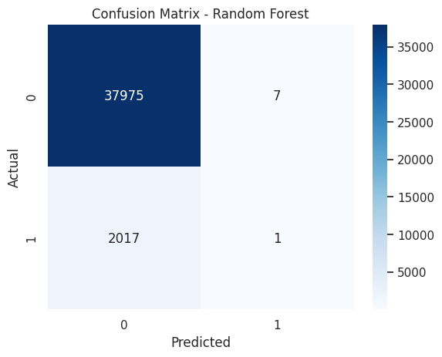
Figure 37: Confusion Matrix -Random Forest

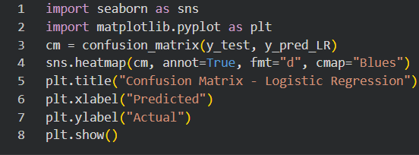
Figure 38: Confusion Matrix
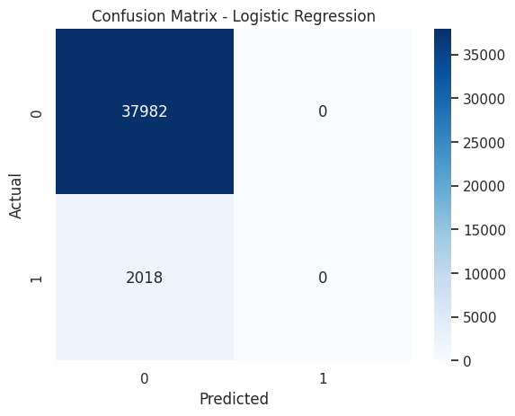
Figure 39: Confusion Matrix -Logistic Regression
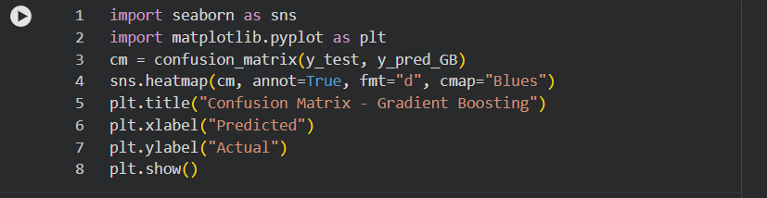
Figure 40: Confusion Matrix
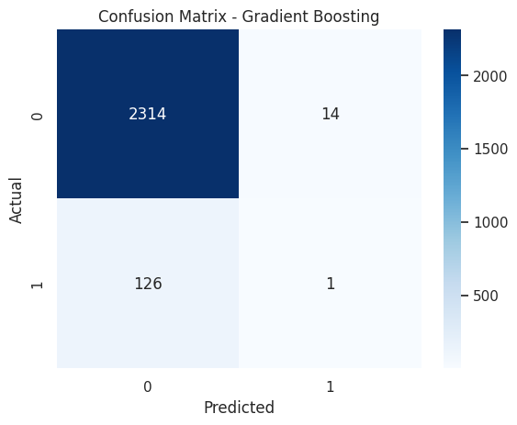
Figure 41: Confusion Matrix- Gradient Boosting

4.5 Feature Importance and Key Fraud Indicators
The feature importance analysis was carried out to identify those features that have a significant impact on detecting fraudulent activities. This analysis involves applying tree-based models like Random Forest and Gradient Boosting to derive an importance score based on how well each feature helps minimise classification errors. This helps shift away from the black-box approach and offers valuable insights regarding the factors behind fraud. From the findings of the analysis, it can be seen that the transaction amount is one of the key predictors of fraud. Those transactions with abnormally high amounts have a high probability of being classified as fraudulent because fraudsters seek to maximise their profits.
Transaction Time proved to be another significant feature. Fraudulent behaviour usually takes place at odd times, like late-night times or early mornings, when there are fewer chances of monitoring the activities. Similarly, Transaction Frequency proves to be a crucial element since frequent and rapid transactions in a short period are a sign of abnormal activity. Account Balance is also an important feature for identifying fraudulent behaviour (Albalawi & Dardouri, 2025). It is important to keep track of the transactions made using the card, especially if there have been any abrupt changes in it or if there are deviations in the usual transactions of the customer. Device Type and Transaction Location also turned out to be important in the detection process since transactions made using an unusual device or from an unknown location can be signs of fraud.

4.6 Behavioural Analysis of Transaction Patterns
Behavioural analysis emphasises uncovering any anomalies in the way customers usually execute their financial transactions. It differs from other rule-based methods because behavioural analysis considers how the customer acts in the past, making it more accurate at spotting anomalies. Behavioural analysis reveals that the transactions made by genuine customers show consistency, for example, consistent transaction times, steady expenditure trends, and habitual use of known devices and places. On the other hand, fraudulent transactions tend to show inconsistent trends, for instance, abrupt increases in the number of transactions executed, strange transaction amounts, and uncharacteristic transaction hours. An important point worth noting is that most fraudulent transactions take place in late night or early morning hours.
Moreover, a quick series of transactions over a brief period may suggest possible fraud attacks and compromises to the account. The use of the device and location behaviour is important. Transactions made using new devices and locations are suspicious (Albalawi & Dardouri, 2025). This is even more significant when the amount of money being sent is abnormal or at an unusual time. In addition, the findings of the study indicated that customers of middle age experienced more incidents of fraud. This is because they engaged in more financial transactions than other age groups.

4.7 System-Level Considerations in Fraud Detection
Apart from the performance of the models, the deployment of effective fraud detection relies heavily on the quality of design and implementation of the solution in real-world scenarios. One of the most important aspects of an anti-fraud system is its ability to operate in real-time mode, which implies instantaneous evaluation of transactions and their protection against fraudsters. It requires the use of low-latency data pipelines and models that can predict outcomes on the fly, in milliseconds (Ali, 2022). There is a compromise between the complexity of the model and the latency in predictions. Although Random Forest and Gradient Boosting offer higher accuracy, they require significant computing resources.
Another aspect to consider is scalability, since financial systems deal with vast amounts of data and transactions that are processed nonstop. A scalable architecture is required in order to accommodate the high amount of transactions processed without a drop in performance, and might need to utilise cloud computing or distributed systems. Data quality assurance also plays an important role, as incorrect or inconsistent data could lead to unreliable results from the models. Connection to banking systems is also imperative since fraud models should be able to integrate into the transaction processing system and provide relevant alerts (Chen et al., 2025). Proper alert management is required in order to achieve the right balance between detecting fraudulent behaviour and preventing too many false alerts.

4.8 Visualisation and Dashboard Insights
The Power BI dashboard is interactive and gives a complete overview of fraud detection trends using several visualisation features in three major areas: Fraud Transaction Overview, Customer Behaviour Analysis, and Fraud Transaction Investigation. The visualisations help users analyse data interactively and derive important information from it. Under the Fraud Transaction Overview section, KPIs indicate that the dataset contains roughly 200K transactions, out of which 10K are classified as fraudulent cases, giving a fraud rate of 5.04%. The daily fraud trend line graph shows variations in fraud incidents during the month of January 2025. There were some spikes in the number of fraud incidents during this period. The doughnut chart depicts the inequality between honest and fraudulent transactions, making it clear that the task at hand is difficult for machine learning algorithms.
Device-based analysis demonstrates that fraud occurs on several platforms, including desktops, POS terminals, ATMs, and mobile phones, implying that fraud is not channel-specific and happens throughout several transaction channels. Merchant category analysis also shows that merchant categories like clothes stores, grocery stores, and restaurants have higher incidences of fraud compared to other categories. Customer Behaviour Analysis gives detailed information about customer demographics. Fraud incidence is higher in middle-aged customers (35-64 years old), probably because they do more financial activities than younger or older people. Gender distribution seems almost equal, implying that fraud is not significantly associated with any particular gender (Aros et al., 2024). Device usage patterns show the prevalence of fraud cases in different transaction devices that are widely used by customers. The Fraud Transaction Investigation page gives a transaction-wise view of fraud incidents, where customers can easily detect and investigate fraudulent transactions by applying filters and conditional formatting.
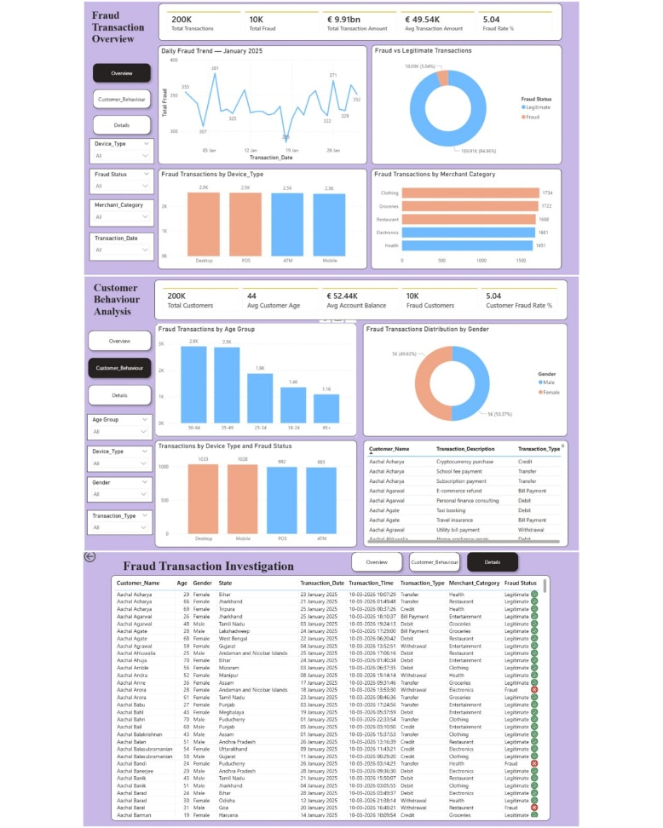
Figure 42: Power BI Fraud Detection Dashboard
Overall, the dashboard indicates that fraud detection should be based on temporal, behavioural, and transactional analysis. The incorporation of interactive visualisation facilitates decision-making by allowing interested parties to track trends, pinpoint risky segments, and detect abnormalities.

4.9 Integrated Discussion of Model Performance
The performance of the machine learning models indicates a common trend; i.e., high accuracy but poor performance in terms of the ability to detect cases of fraud. The main reason behind this phenomenon is the presence of a serious class imbalance in the given dataset, which means that most of the records belong to the majority class. Consequently, models have a tendency to predict the majority class, resulting in good overall accuracy but low fraud detection. All three models showed accuracy levels that were close to 95%. Nevertheless, all the models had extremely low values of recall and F1-scores, which means that they cannot recognise cases of fraud. Such results show one significant drawback of optimising models in terms of accuracy. Models that achieve the highest levels of accuracy might not be appropriate when solving problems with class imbalance. In fraud detection, missing cases of fraud have a higher cost than making false positives. The only exception to this rule was the Decision Tree algorithm, which had lower accuracy levels (around 87.6%).
This implies that simple models may be able to detect patterns among the minority class much better than complicated models due to their unbiased nature towards the majority class. It was also found that complexity is not necessarily an indicator of better results. For example, Random Forest and Gradient Boosting could not perform any better in detecting fraud compared to other methods. Thus, besides model choice, the structure and distribution of the dataset were also responsible for poor results. The analysis of the confusion matrix corroborates these findings by pointing out the large amount of false negatives reported for the high-accuracy models (Ali et al., 2023). This highlights the necessity of concentrating on the recall metric in order to minimise the number of fraud cases that the model misses. In conclusion, the combined analysis proves that there are several ways of improving the fraud detection process, which include dealing with class imbalance, adjusting thresholds, using state-of-the-art machine learning algorithms, such as XGBoost, and applying advanced feature engineering.
The general consistency of the ensemble models such as the Random Forest and Gradient Boosting was good, yet the fact that they could not identify the cases of fraud implies that the accuracy cannot be considered the sole measure of performance in the absence of balance. The finding contributes to the scholarly debate of detecting fraud by demonstrating that recall and F1-score are more meaningful performance metrics. In addition, the high recall of the Decision Tree shows that interpretable models can be more useful in high-stakes finance when transparency and compliance with regulations are important.

4.10 Key Findings and Empirical Insights
This study highlights some essential insights regarding the use of machine learning algorithms in detecting fraud through financial transactions. The primary conclusion drawn from this study is that high model accuracy is not enough for successful fraud detection. Despite achieving up to 95% accuracy rates, the models based on Logistic Regression, Random Forest, and Gradient Boosting could not detect any fraudulent transactions, as indicated by their extremely low recall and F1-scores. Therefore, accuracy is not an effective metric for measuring the performance of models trained on highly imbalanced datasets. Empirically, one crucial aspect that significantly influences the behaviour of the models used in this study is class imbalance. As legitimate transactions greatly outnumber fraudulent transactions in the dataset, most models will predict the majority class, leading to high rates of true negatives but low fraud detection rates.
However, the Decision Tree model with an overall accuracy of approximately 87.6% performed much better with respect to fraud transaction identification. It demonstrated higher values of recall and F1-score compared to other models, thus showing the ability to capture patterns of the minority class to some extent. The example demonstrates that sometimes simple algorithms are better at detecting rare occurrences when compared to more complicated techniques that tend to focus on the majority class. Moreover, it is necessary to point out the fact that increasing the complexity of the model does not always result in its higher performance. In this regard, both Random Forest and Gradient Boosting, as advanced models, demonstrated worse results in comparison with other algorithms.
Based on the feature analysis, transaction-level variables, including the amount, time, device type, and merchant category, had an important influence on the prediction results. Transactions conducted in a fraudulent manner exhibited irregularities, such as the unusual timing of transactions or the use of several devices for carrying out these transactions. Moreover, the Power BI dashboard offered useful insights on fraud behaviour through its visualisation capabilities, which included trends at different points in time, different customer segments, and transaction channels. The findings of the study highlight that detecting fraud requires not only accurate assessment measures but also effective data management and relevant features, along with appropriate modelling methods.

4.11 Summary
This chapter analysed the performance of various machine learning algorithms for the task of detecting fraud, as well as provided valuable insights from the process of data visualisation. From the results, it was clear that even though some models, such as the Random Forest Classifier, Logistic Regression Model, and Gradient Boosting Model, had high prediction accuracy, none of them managed to detect fraudulent transactions due to the unbalanced data. The Decision Tree Classifier model was better at identifying fraudulent transactions compared to others; however, the model's low accuracy indicates that fraud detection is better measured by recall and F1 scores instead of accuracy, since the goal of detecting fraudulent transactions should come first, regardless of accuracy. It is important to note that the confusion matrix analysis helped identify the crucial problem of false negatives when predicting fraudulent transactions, which should be prevented in any case, since a false negative can have disastrous consequences. Apart from that, the Power BI dashboard was able to provide useful insights into the patterns of fraud based on time, customer, device used for the transaction, and merchant category. The findings establish a strong foundation for improving model performance, which is further discussed in the subsequent chapter.

Chapter 5: Conclusion
In this research, I have been successful in creating an intelligent fraud detection system using machine learning techniques as well as a business intelligence visualisation tool. The study mainly concentrated on analysing banking transactions' data to detect any fraud and to determine the efficiency of various classification models in detecting any fraud. Data preprocessing, exploratory data analysis, feature engineering, encoding of categorical data, as well as the SMOTE technique, were used to pre-process the data before creating the model.
Several models, such as Logistic Regression, Decision Tree, Random Forest, and Gradient Boosting, have been considered for modelling. They have been tested using accuracy, precision, recall, F1-score, and confusion matrix measures. It has been found that despite the relatively high accuracy achieved by these models, they are rather ineffective in detecting fraud because of a significant imbalance in classes. The Decision Tree model showed relatively better results among all the analysed models for fraud detection. Furthermore, according to the study, recall and F1-score are much better measures than accuracy to be used in evaluating the Fraud Detection System performance. The dashboard created using Power BI provided great insights for understanding the transaction data.

5.1 Summary of Findings
This study investigated machine learning algorithms in detecting banking fraud based on transaction data. Since fraud datasets are highly imbalanced, methods including data cleaning, feature engineering, categorical encoding, and class balancing based on the use of SMOTE methods were used. The machine learning algorithms, which include Logistic Regression, Decision Tree, Random Forest, and Gradient Boosting, have been put to test considering the accuracy, precision, recall, F1-score and analysis of a confusion matrix. The results indicated that effectiveness in fraud detection requires accuracy, as not all models detected fraudulent transactions. The Decision Tree algorithm performed the best with regard to fraud detection. Behavioural analysis and Power BI dashboards were also of great help.

5.2 Research Contributions
The study has three significant contributions:
- It demonstrates that accuracy is inadequate to detect fraud, and recall and F1-score are crucial to evaluate models.
- It includes machine learning and Power BI dashboards and provides a new framework, enhancing interpretability and supports the decision-making process in a banking environment.
- It addresses the issue of the class imbalance by using SMOTE and proves that preprocessing can provide a huge improvement to the minority classes detection. All these contributions lead to the development of academic knowledge and the implementation of fraud detection systems.
The study makes a valuable contribution to the research topic under discussion through the creation of an integrated framework aimed at applying machine learning and business intelligence visualisation for fraud detection in banking organisations. One of the main contributions made by this research lies in comparing different types of classifiers to test their capacity to analyse imbalanced banking datasets. In this case, the researcher applied classifiers such as Logistic Regression, Decision Tree, Random Forest, and Gradient Boosting. Another contribution relates to revealing the limits of utilising accuracy as the sole measure of performance for fraud detection models. According to the results obtained in the experiment, high precision does not always guarantee low rates of fraud, and therefore, one needs to consider other parameters like recall, F1-score, and false negatives.
Another important contribution is connected with the usage of data processing and balancing methods, namely, feature engineering, encoding, and SMOTE, in order to enhance the learning ability of machine learning models. Moreover, the paper contributes to the analysis by providing an example of integrating Power BI dashboards that allow conducting fraud investigations and analyses of customer behaviour in banking organisations.

5.3 Recommendations
From the findings in this study, a number of suggestions are made regarding how to optimize fraud detection systems within financial institutions. First, priority should be placed on metrics such as recall, F1 score, and false negatives rather than accuracy in evaluating fraud detection systems. In the context of fraud detection systems, overlooking any transaction that might prove to be fraudulent can have significant adverse consequences both financially and reputationally. The success rate in detecting fraud becomes more important than overall accuracy in this situation. Secondly, more complex approaches to balancing class distribution should be considered.
For instance, while SMOTE performed better than other approaches used in the current study, other approaches, such as cost-sensitive learning, ensemble balancing, and adaptive learning techniques, could yield even more promising results when applied to fraud detection. Also, more sophisticated machine learning approaches, such as XGBoost, LightGBM, and deep learning-based approaches, should be considered by financial institutions in order to capture more complex and nonlinear fraudulent activities. Lastly, the implementation of real-time fraud detection mechanisms coupled with interactive visualisations via tools such as Power BI would be highly useful.
With the presented framework, financial institutions can reduce financial losses, build greater customer trust, and become more compliant with regulatory frameworks, such as PSD2 and GDPR. Incorporating the fraud detection insights into the interactive dashboards will enable the banks to empower the analysts and managers to respond more effectively and promptly to suspicious activity.

5.4 Future Research
Future research can be oriented on:
- Stream pipelines to identify fraud in real-time on the basis of streaming infrastructure, such as Apache Kafka or Spark streaming.
- Explainable AI (XAI) methods (e.g., SHAP, LIME) to increase transparency and compliance with regulations.
- Federated learning models enabling a group of banks to jointly train fraud detection models without sensitive customer information.
- Graph detection of fraud based on complex account, device and transaction relationships. These guidelines would take the current studies to the cutting-edge areas of financial technology.
In spite of the success attained by this study in developing a machine learning-based fraud detection framework, there still exist several potential areas for future exploration. Future studies may concentrate on exploring advanced machine learning and deep learning algorithms such as XGBoost, LightGBM, Artificial Neural Networks (ANN), and LSTM in enhancing the ability of detecting frauds and predicting the minority classes. Other interesting topics for investigation in the future might involve real-time fraud detection through analysing streaming transactions. Incorporation of machine learning algorithms with Cloud Computing platforms will be useful in achieving immediate fraud detection and fast reaction mechanisms in banking.
Hybrid approaches involving machine learning techniques, anomaly detection, and rule-based systems might be explored in future studies to enhance predictive capabilities and the understandability of the algorithms used. Explaining Artificial Intelligence (XAI) methods may also be explored in future studies to achieve better transparency in decision-making when performing fraud prediction tasks. Other promising topics include the utilisation of bigger datasets from other banks as well as the application of different methods of integrating behavioural biometrics and geolocation in fraud detection efforts. Finally, the integration of Graph Theory in fraud detection might be applied to achieve a better understanding of cybercrime network dynamics.

References
AbouGrad, H. and Sankuru, L., 2025. Online banking fraud detection model: Decentralized machine learning framework to enhance effectiveness and compliance with data privacy regulations. Mathematics, 13(13), p.2110. https://doi.org/10.3390/math13132110
Alamri, M. and Ykhlef, M., 2024. Hybrid feature engineering based on customer spending behavior for credit card anomaly and fraud detection. Electronics, 13(20), p.3978. https://doi.org/10.3390/electronics13203978
Aljunaid, S.K., Almheiri, S.J., Dawood, H. and Khan, M.A., 2025. Secure and transparent banking: Explainable AI-driven federated learning model for financial fraud detection. Journal of Risk and Financial Management, 18(4), p.179. https://doi.org/10.3390/jrfm18040179
Arzu, F., Bajwa, M.K.Z., Waheed, A., Alam, F., Ali, M. and Khan, A., 2025. Real-Time Financial Fraud Detection: An Intelligent Data-Driven Framework Integrating Machine Learning, Stream Processing, and Big Data Analytics for High-Velocity Transaction Monitoring. The Asian Bulletin of Big Data Management, 5(4), pp.124-154. https://doi.org/10.62019/f3c0g313
Baisholan, N., Dietz, J.E., Gnatyuk, S., Turdalyuly, M., Matson, E.T. and Baisholanova, K., 2025. FraudX AI: An interpretable machine learning framework for credit card fraud detection on imbalanced datasets. Computers, 14(4), p.120. https://doi.org/10.3390/computers14040120
Compagnino, A.A., Maruccia, Y., Cavuoti, S., Riccio, G., Tutone, A., Crupi, R. and Pagliaro, A., 2025. An introduction to machine learning methods for fraud detection. Applied Sciences, 15(21), p.11787. https://doi.org/10.3390/app152111787
Dichev, A., Zarkova, S. and Angelov, P., 2025. Machine learning as a tool for assessment and management of fraud risk in banking transactions. Journal of Risk and Financial Management, 18(3), p.130. https://doi.org/10.3390/jrfm18030130
Gonçalves, C.T., Gonçalves, M.J.A. and Campante, M.I., 2023. Developing integrated performance dashboards visualisations using Power BI as a platform. Information, 14(11), p.614. https://doi.org/10.3390/info14110614
Hernandez Aros, L., Bustamante Molano, L.X., Gutierrez-Portela, F., Moreno Hernandez, J.J. and Rodríguez Barrero, M.S., 2024. Financial fraud detection through the application of machine learning techniques: a literature review. Humanities and Social Sciences Communications, 11(1), pp.1-22. https://doi.org/10.1057/s41599-024-03606-0
Iqbal, S., Awan, K.M., Kamal, S. and Rehman, Z.U., 2025. Interpretable Ensemble Learning Models for Credit Card Fraud Detection. Applied Sciences, 15(22), p.12073. https://doi.org/10.3390/app152212073
Moradi, F., Tarif, M. and Homaei, M., 2025. A systematic review of machine learning in credit card fraud detection. Preprint, MDPI AG. https://doi.org/10.20944/preprints202507.1085.v1
Moura, L., Barcaui, A. and Payer, R., 2025. AI and financial fraud prevention: Mapping the trends and challenges through a bibliometric lens. Journal of Risk and Financial Management, 18(6), p.323. https://doi.org/10.3390/jrfm18060323
Nobel, S.N., Sultana, S., Singha, S.P., Chaki, S., Mahi, M.J.N., Jan, T., Barros, A. and Whaiduzzaman, M., 2024. Unmasking banking fraud: Unleashing the power of machine learning and explainable ai (xai) on imbalanced data. Information, 15(6), p.298. https://doi.org/10.3390/info15060298
Preciado Martínez, P.M., Reier Forradellas, R.F., Garay Gallastegui, L.M. and Náñez Alonso, S.L., 2025. Comparative analysis of machine learning models for the detection of fraudulent banking transactions. Cogent Business & Management, 12(1), p.2474209. https://doi.org/10.1080/23311975.2025.2474209
Wen, J., Tang, X. and Lu, J., 2024. An imbalanced learning method based on graph tran-smote for fraud detection. Scientific Reports, 14(1), p.16560. https://doi.org/10.1038/s41598-024-67550-4
Wu, Y., Wang, L., Li, H. and Liu, J., 2025. A deep learning method of credit card fraud detection based on continuous-coupled neural networks. Mathematics, 13(5), p.819. https://doi.org/10.3390/math13050819
Yaseen, H. and Al-Amarneh, A.A., 2025. Adoption of artificial intelligence-driven fraud detection in banking: The role of trust, transparency, and fairness perception in financial institutions in the United Arab Emirates and Qatar. Journal of Risk and Financial Management, 18(4), p.217. https://doi.org/10.3390/jrfm18040217
Ahad Hassan Farroqi, A. (2026). Improving Fraud Detection Systems Using Deep Learning with Resampling Techniques. Journal of Hunan University Natural Sciences. doi: https://doi.org/10.55463/issn.1674-2974.53.4.1.
Albalawi, T. and Dardouri, S. (2025). Enhancing credit card fraud detection using traditional and deep learning models with class imbalance mitigation. Frontiers in Artificial Intelligence, 8. doi: https://doi.org/10.3389/frai.2025.1643292.
Chang, V., Ali, B., Golightly, L., Meghana Ashok Ganatra and Mohamed, M. (2024). Investigating Credit Card Payment Fraud with Detection Methods Using Advanced Machine Learning. Information, [online] 15(8), pp.478–478. doi: https://doi.org/10.3390/info15080478.
Chew, P., Yang, Y. and Lee, B.-G. (2023). Enhancing Financial Fraud Detection through Addressing Class Imbalance Using Hybrid SMOTE-GAN Techniques. International Journal of Financial Studies, 11(3), pp.110–110. doi: https://doi.org/10.3390/ijfs11030110.
Dichev, A., Zarkova, S. and Angelov, P. (2025). Machine Learning as a Tool for Assessment and Management of Fraud Risk in Banking Transactions. Journal of Risk and Financial Management, [online] 18(3), pp.130–130. doi: https://doi.org/10.3390/jrfm18030130.
Hayat, K. and Magnier, B. (2025). Data Leakage and Deceptive Performance: A Critical Examination of Credit Card Fraud Detection Methodologies. Mathematics, [online] 13(16), p.2563. doi: https://doi.org/10.3390/math13162563.
Hisham AbouGrad and Lakshmi Sankuru (2025). Online Banking Fraud Detection Model: Decentralised Machine Learning Framework to Enhance Effectiveness and Compliance with Data Privacy Regulations. Mathematics, [online] 13(13), pp.2110–2110. doi: https://doi.org/10.3390/math13132110.
Olowu, N.O., Adeleye, O., Okandeji, A., Ajayi, M., Adebayo, N., Omole, M. and Chianumba, E.C. (2024). AI-driven Fraud Detection in banking: a Systematic Review of Data Science Approaches to Enhancing Cybersecurity. GSC Advanced Research and Reviews, 21(2), pp.227–237. doi: https://doi.org/10.30574/gscarr.2024.21.2.0418.
Preciado Martínez, P.M., Reier Forradellas, R.F., Garay Gallastegui, L.M. and Náñez Alonso, S.L. (2025). Comparative Analysis of Machine Learning Models for the Detection of Fraudulent Banking Transactions. Cogent Business & Management, 12(1). doi: https://doi.org/10.1080/23311975.2025.2474209.
Ramesh, P. (2025). Leveraging Power BI for Business Intelligence in the Financial Sector: a Case Study Approach. World Journal of Advanced Research and Reviews, [online] 26(3), pp.2844–2855. doi: https://doi.org/10.30574/wjarr.2025.26.3.2415.
Rashedi, K.A., Ismail, M.T., Al Wadi, S., Serroukh, A., Alshammari, T.S. and Jaber, J.J. (2024). Multi-Layer Perceptron-Based Classification with Application to Outlier Detection in Saudi Arabia Stock Returns. Journal of Risk and Financial Management, [online] 17(2), p.69. doi: https://doi.org/10.3390/jrfm17020069.
Sharma, A., Sharma, S., Malik, A., Sobti, R. and Suryana, A. (2025). Dynamic Feature Engineering for Adaptive Fraud Detection. The 7th International Global Conference Series on ICT Integration in Technical Education & Smart Society, [online] p.68. doi: https://doi.org/10.3390/engproc2025107068.
Aburbeian, AlsharifHasan Mohamad and Ashqar, Huthaifa I (2023). Credit Card Fraud Detection Using Enhanced Random Forest Classifier for Imbalanced Data. arXiv (Cornell University). doi: https://doi.org/10.48550/arxiv.2303.06514.
Albalawi, T. and Dardouri, S. (2025). Enhancing credit card fraud detection using traditional and deep learning models with class imbalance mitigation. Frontiers in Artificial Intelligence, 8. doi: https://doi.org/10.3389/frai.2025.1643292.
Ali, A. (2022). Financial Fraud Detection Based on Machine Learning: A Systematic Literature Review. Applied Sciences, [online] 12(19). doi: https://doi.org/10.3390/app12199637.
Ali, A.A., Khedr, A.M., El-Bannany, M. and Kanakkayil, S. (2023). A Powerful Predicting Model for Financial Statement Fraud Based on Optimised XGBoost Ensemble Learning Technique. Applied Sciences, [online] 13(4), p.2272. doi: https://doi.org/10.3390/app13042272.
Aros, L.H., Ximena, L., Gutierrez-Portela, F., Johver, J. and Samuel, M. (2024). Financial fraud detection through the application of machine learning techniques: a literature review. Humanities and Social Sciences Communications, [online] 11(1). doi: https://doi.org/10.1057/s41599-024-03606-0.
Chen, Y., Zhao, C., Xu, Y. and Nie, C. (2025). Year-over-Year Developments in Financial Fraud Detection via Deep Learning: A Systematic Literature Review. [online] arXiv.org. Available at: https://arxiv.org/abs/2502.00201.
Kulbayeva, A.K., Rakhmetulayeva, S.B., Bolshibayeva, A.K. and Yasar, A.-U.-H. (2024). Data Processing Methods for Financing Terrorism: The Role of Microsoft Power BI in Money Laundering Detection. Procedia Computer Science, [online] 238, pp.528–535. doi: https://doi.org/10.1016/j.procs.2024.06.056.
Şeker, Ş. and Dayioğlu, T. (2025). Credit Card Fraud Detection Using Machine Learning Models: A Performance Comparison. 2025 33rd Signal Processing and Communications Applications Conference (SIU), [online] pp.1–4. doi: https://doi.org/10.1109/siu66497.2025.11112091.
Velarde, G., Sudhir, A., Deshmane, S., Deshmunkh, A., Sharma, K. and Joshi, V. (2023). Evaluating XGBoost for Balanced and Imbalanced Data: Application to Fraud Detection. arXiv (Cornell University). doi: https://doi.org/10.48550/arxiv.2303.15218.
Yapp, E.K.Y. and Yeh, H.-Y. (2026). An extensive experimental comparison of machine and deep learning methods for credit and bank fraud detection. Finance Research Letters, 88, p.109190. doi: https://doi.org/10.1016/j.frl.2025.109190.

Appendices

Dataset variables


Model outputs












Dashboard screenshots


Code snippets
